

The University of Hong Kong MSc(BA)

Capstone Project

Dissertation Title:
Li-Ning Decoding Retail Success: Foot Traffic Analysis of Li-Ning New Category Store and Data-Driven Location
—— Micro-Modeling and Customer Insights for Sales and Assortment Optimization

Team: Mao Xiaojing, Sun Jin, Li Huyun, Xu Zheying,
Deng Shiyan, Zhuang Yayin, Qian Puyue, Liang Jingjun
UID: 3036552607, 3036604814, 3036346187, 3036553091,
3036551524, 3036553912, 3036551665

Supervisor: Prof. Zhang Wei
Date of submission: 10/05/2026

Contents
1. Background and Objective 4
1.1 Background of Li-Ning LOONG STORE 4
1.2 Existing Data Assets 4
1.3 Project Objective and Overall Approach 5
2. Descriptive Analysis 6
2.1 Overall Sales Distribution 6
2.2 Sales Trends and Periodicity 7
2.3 Store-Level Key Revenue Drivers 7
2.4 Product Series Composition 8
2.5 Relationship Between Sales Performance and Consumer Demographics 9
3. Series Allocation Modelling Methodology 13
3.1 Introduction 13
3.2 Cluster Analysis Based on 15 Pop-Up Stores 13
3.3 Customer segments detail for each cluster: 13
3.4 Data Preparation 14
3.5 Train MNL Model 14
3.6 Apply Model to All Commercial Complexes 15
3.7 Product Mix Recommendations 15
3.8 Series Allocation Recommendations 15
3.9 AI-Assisted Assortment Recommendation System: Implementation and Testing Report 17
4. Modeling 25
4.1 Method Overview 25
4.2 Product selection risk assessment tool: Store type identification and category classification range 25
4.3 Product selection risk grading tool: Product line grading mapping and feature association 34
4.4 Execution Summary 42
4.5 Methodological Framework 43
4.6 Scoring Card Design: D. Method for Generating the Total Score 44
4.7 Cross-Week Stability of Store Classification 52
4.8 Recommended range for double-layer ratio 55
4.9 K-NN Similar Store Search Method (Core Method) 57
4.10 LOO Accuracy Verification 59
4.11 Validation of the Importance of Random Forest Features 60
4.12 GBM Parts Percentage Prediction 61
4.13 Decision Matrix (6 Combinations of Shopping Mall Signals) 63
4.14 Limitations 64
5. Conclusion and Future 66
5.1 Core Project Summary 66
5.2 Future Outlook 67

Background and Objective

Background of Li-Ning LOONG STORE
LI-NING LOONG STORE represents one of the brand’s most important retail formats in high-potential commercial locations. In addition to serving as a point of sale, it also functions as a key vehicle for brand expression, new product presentation, and consumer engagement. Compared with conventional retail outlets, the LOONG STORE and pop-up formats place greater emphasis on thematic merchandising, series presentation, and the alignment between product structure and target consumer profile.
As LI-NING continues to expand across cities and commercial complexes of different types, the key business question is no longer simply whether a new store can generate sales, but rather how to configure an appropriate merchandise structure for a given location and consumer environment. This issue is particularly important for pop-up stores, which typically operate within a shorter time horizon and therefore rely more heavily on an effective initial product mix. Under such circumstances, once the location and host commercial complex have already been determined, improving the quality of pre-opening merchandising decisions becomes critical to enhancing early-stage store performance.

Existing Data Assets
This project is supported by two major categories of data.
The first is historical pop-up store sales panel data, covering 15 stores, 9 weeks, and 65 store-week observations. This dataset captures sales quantity, sales revenue, and ticketed value across different series, categories, and individual products. As a result, it provides a sufficiently detailed view of each store’s sales structure and allows the analysis to move beyond total sales into series-level and product-level composition.
The second is consumer profile data for the commercial complexes in which these stores are located. These variables include city tier, working and residential population within 1 km and 3 km, age distribution, gender distribution, affluence level, and mobile phone brand preference. Together, these indicators describe the consumer base and catchment characteristics surrounding each store location.
Taken together, the current data is well suited to addressing the following question: given a predetermined location and a known consumer profile, what type of merchandise structure is likely to be most appropriate for a newly opened store?

Project Objective and Overall Approach
The core objective of this tool is to support pre-opening assortment planning for LI-NING when a new store location has already been selected. After entering six profile features of the target commercial complex, the team should be able to obtain within five minutes: the recommended tier (Premium / Balanced / Mass), the reference mix range for major categories (Footwear / Apparel / Accessories), the reference mix range for product lines (Rongyao / Gold Label / Others), and corresponding risk alerts.
Accordingly, the key business question is: given the profile features of a new commercial complex, how can we recommend a practical and reasonable merchandise mix for launch?
The method is designed as a two-step progressive process. Step 1 is a scorecard module: the six profile features are transformed into a composite score between 1.00 and 3.00, and tercile cutoffs are used to classify the location into three tiers (Premium / Balanced / Mass). This scorecard is a simplified version of the tool and is suitable for quick first-pass judgement. Step 2 is a K-nearest-neighbors (K-NN) similar-store search, which is the core method. In feature space, the model finds historical stores most similar to the new location and directly uses their observed mix structures as reference intervals.

Descriptive Analysis
This chapter provides a comprehensive descriptive analysis of pop-up store operations, focusing on weekly sales distributions, regional performance variations, and consumer profile characteristics.

Overall Sales Distribution
The primary KPI analyzed is Weekly Total Sales (denominated in 10k RMB). The weekly sales data exhibits a significant right-skewed distribution. Most pop-up stores generate weekly revenue between 0 and 500,000 RMB. However, there are specific storess reaching upwards of 1.2M - 1.5M RMB per week. This suggests that while baseline performance is consistent, a small number of stores achieve exceptional revenue in specific weeks, likely driven by peak time and premium locations.
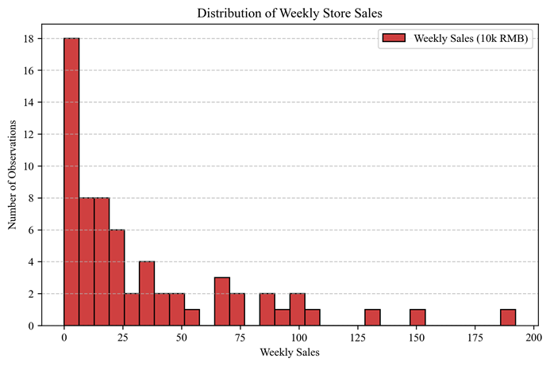
The average weekly sales analysis by location reveals a clear hierarchy among the pop-up stores, highlighting significant disparities in revenue generation across different commercial environments. The Beijing Sanlitun and Shanghai Xintiandi locations emerge as the undisputed performance leaders. The dominance of these malls suggests that store performance is highly reliant on the "anchor effect" of the hosting commercial complex. The high-spending foot traffic of these specific malls is the primary driver of the observed sales peaks.
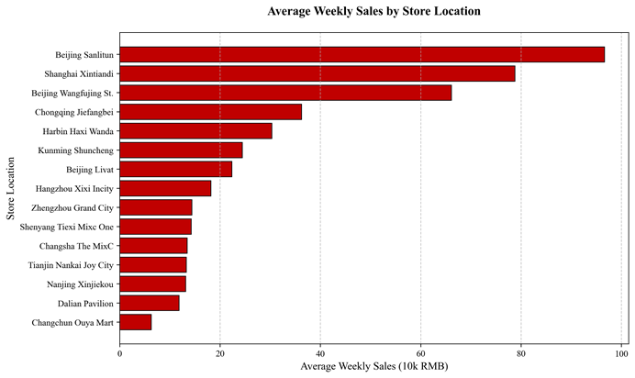

Sales Trends and Periodicity
This chart shows the fluctuations in average weekly sales over the observation period. A major sales surge is observed during Spring Festival, which indicates a period of exceptional consumer engagement, where weekly revenue reached its maximum across all locations.
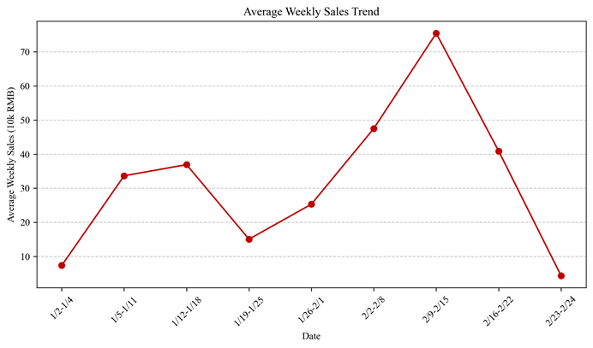

Store-Level Key Revenue Drivers
To identify the primary revenue drivers for the pop-up stores, the analysis breaks down sales performance by product category. The business is heavily driven by Footwear and Apparel, which together account for the vast majority of total turnover. Footwear, in particular, maintains a consistently high share across most locations, often serving as the category that secures baseline revenue.
When examining individual stores, we find that some locations are almost exclusively footwear-driven, others show a more balanced split with apparel. This suggests that the product mix of different pop-up stores should adapt to local consumer preferences and store-specific assortments.
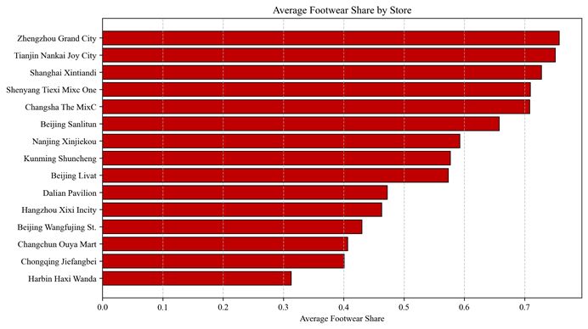

Product Series Composition
To further explore the structure of sales, the analysis decomposes total sales by product series using sales volume rather than sales value. This approach ensures that the results better capture actual consumer demand rather than price effects. The total sales of each store are divided into several key series, including National Team, Li-Ning Glory, Li-Ning Glory Premium, and Other Series. By calculating the proportion of each series relative to total sales, the product mix of each store is clearly identified.
Pop-up Stores | Dominant Series | Dominant Series Share | National Team Share | Li-Ning Glory Share | Li-Ning Glory Premium Share | Other Series Share
Shanghai Xintiandi | Other Series | 56.45% | 10.57% | 19.80% | 13.18% | 56.45%
Beijing Sanlitun | Li-Ning Glory | 50.47% | 5.27% | 50.47% | 20.88% | 23.38%
Beijing Wangfujing Street | Li-Ning Glory | 53.19% | 13.20% | 53.19% | 23.20% | 10.41%
Beijing Livat | Other Series | 51.33% | 0.00% | 39.49% | 9.18% | 51.33%
Nanjing Xinjiekou | Li-Ning Glory | 83.34% | 0.00% | 83.34% | 16.66% | 0.00%
Harbin Haxi Wanda Plaza | Li-Ning Glory | 76.93% | 0.00% | 76.93% | 23.07% | 0.00%
Dalian Pavilion | Li-Ning Glory | 80.00% | 0.00% | 80.00% | 20.00% | 0.00%
Tianjin Nankai Joy City | Li-Ning Glory | 65.25% | 0.00% | 65.25% | 19.25% | 15.50%
Kunming Shuncheng Shopping Center | Li-Ning Glory Premium | 74.78% | 1.13% | 21.84% | 74.78% | 2.24%
Hangzhou Xixi Incity | Li-Ning Glory | 62.55% | 0.00% | 62.55% | 36.09% | 1.36%
Shenyang Tiexi Mixc One | Li-Ning Glory | 69.26% | 0.00% | 69.26% | 30.74% | 0.00%
Zhengzhou Grand City | Li-Ning Glory | 82.32% | 0.00% | 82.32% | 17.68% | 0.00%
Chongqing Jiefangbei | Other Series | 43.91% | 6.02% | 31.04% | 19.02% | 43.91%
Changchun Ouya Mart | Li-Ning Glory Premium | 48.76% | 0.00% | 45.84% | 48.76% | 5.40%
Changsha The MixC | Li-Ning Glory | 49.21% | 1.79% | 49.21% | 35.07% | 13.94%
The identification of a dominant series provides a critical foundation for our predictive modeling and future site selection. Most stores are characterized by a clearly identifiable dominant series, which often account for over 50% of total sales volume. This categorization is instrumental for our subsequent modeling. By mapping the commercial attributes of a new mall to those of our existing successful pop-ups, we can generate high-value recommendations.

Relationship Between Sales Performance and Consumer Demographics
To understand the drivers behind revenue variance, we analyzed the relationship between weekly sales and key consumer profile indices.

Gender Distribution and Sales Correlation
The scatter plots indicate a clear gender-based performance gap. Sales exhibit a significant upward trend as the male ratio exceeds the 0.50 threshold. Conversely, the female ratio shows an inverse relationship, where higher female concentrations generally correlate with lower sales volume, suggesting the sales has a much stronger appeal within the male demographic.
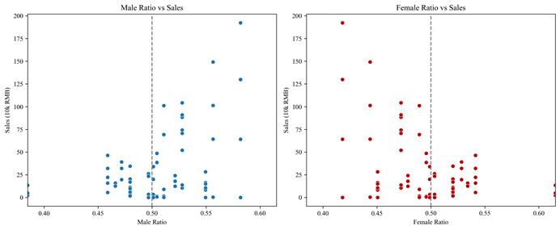

Socioeconomic Class and Sales Correlation
The relationship between social class and weekly sales reveals distinct patterns.
Working class shows a positive relation with sales. Higher sales are achieved when this group constitutes 40% or more of the population, indicating a strong volume-based foundation.
Affluent middle class, upper middle class and high net worth show a fragmented distribution. Their increased ratio does not linearly drive sales, suggesting a ceiling effect.
Ultra-high net worth account for very small proportion. However, a slight increase in the presence of these individuals often triggers disproportionate spikes in sales.
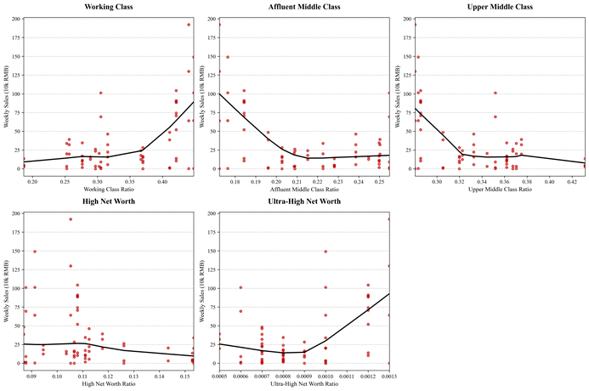

Age Demographic and Sales Correlation
The trend analysis across different age cohorts reveals that senior users are the primary drivers of growth. There is a robust positive correlation between sales and the share of customers aged 50-64. As the share of users aged 50-54, 55-59, and 60-64 increases, the regression line goes upward sharply.
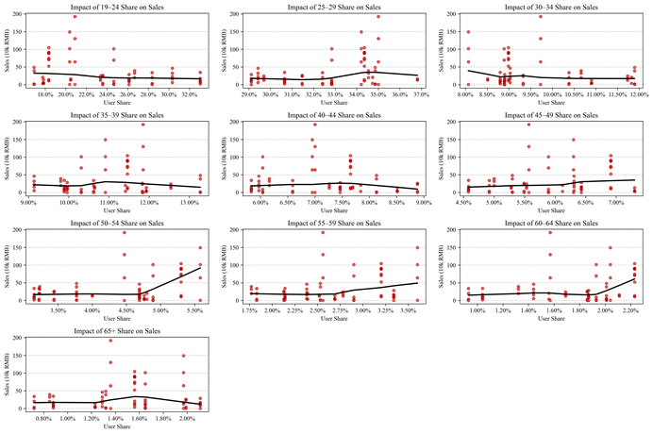

Smartphone Brands and Sales Correlation
User device preference serves as a significant predictor of purchasing power and behavior. There is a strong positive correlation between the share of Apple users and sales. Sales experience exponential growth as the Apple user share rises above 15%, identifying this group as the highest-value segment.
Huawei and Honor show no significant correlation with sales. And sales achieves highest point at moderate user shares (33% for Huawei and 16% for Honor).
Xiaomi, OPPO, and Vivo generally exhibit a negative correlation pattern, where higher user shares often align with lower overall sales.
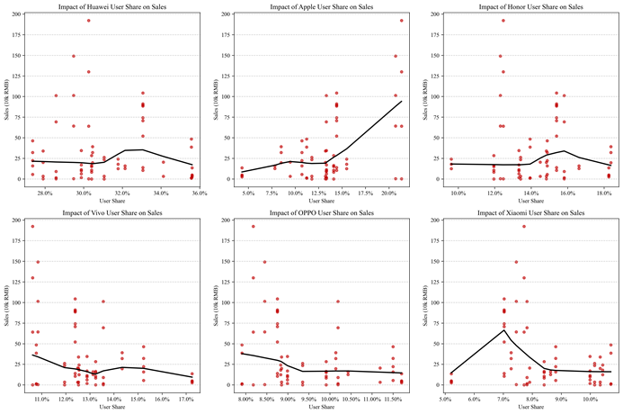

Summary of Key Findings
In conclusion, the analysis reveals that pop-up store performance is heavily driven by prime commercial locations and a robust appeal among male users and senior demographics (aged 50-64). For some stores, footwear and the "Li-Ning Glory" series provide a stable revenue base. And exponential growth of sales is most closely linked to a high concentration of Apple users and high-net-worth individuals. These findings suggest that future site selection and marketing should prioritize high-end commercial hubs that align with these high-value consumer profiles to maximize sales potential.

Series Allocation Modelling Methodology

Introduction
In this section, we used a Multinomial Logit (MNL) model to predict product assortment for commercial complexes which are planning to launch pop-up stores in new cities. The model takes 15 pop-up stores’ historical sales data and customer profile as training inputs. After training, the model is applied to all commercial complexes nationwide to predict two key outputs: (1) the customer segments of each commercial complex; and (2) the recommended sales share for each Li Ning product series based on that customer segment. When launching pop-up stores in new cities, the model supports to predict the optimal inventory proportion for each Li Ning series (“李宁荣耀系列”, “李宁荣耀金标系列”, “国家队系列”, “其他系列”).

Cluster Analysis Based on 15 Pop-Up Stores
Indicator | Description
Young Ratio | Proportion of customers aged 19-29
Female Ratio | Proportion of female
High Purchasing Power | Proportion of customers classified as “super-rich”, “rich”, or “middle-class”
Working Population (3km) | Working population within 3km of the mall
Province Score | Tier-1 cities = 4;  Tier-2 cities = 3;  Tier-3 cities = 2;  Tier-4 cities = 1
The three customer segments were generated from K-Means clustering analysis of the 15 pop-up stores. The clustering is based on five customer profile indicators. The algorithm automatically grouped the 15 stores into three clusters based on the similarity of these indicators. After clustering, we examined the characteristics of each cluster to define the customer segment types.

Customer segments detail for each cluster:
“一线城市标杆店”: High working population and high province score
“女性高潜力店”: High female ratio and high purchasing power
“年轻潮流主力店”: High young ratio

Data Preparation
Before training the model, we first computed sales proportion for each of the 15 pop-up stores across four Li Ning series. We also calculated the average sales share for each customer segment based on the 15 stores’ real sales data.
All records with product hierarchy “推广类” (promotional items/gifts). These are complementary gifts bundled with sales and should not be counted towards actual product sales. Removing them ensures our series share calculations reflect the actual customer purchases.
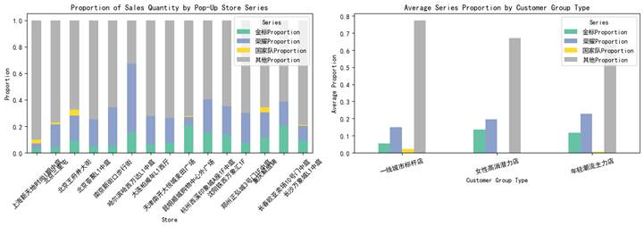
Data standardization was then applied to transform different-scale features to the same scale. This step is necessary because different features have different value ranges. The most obvious example is the young ratio against the working population. The young ratio ranges from 0.5 to 0.7, while the working population (3km) ranges from 100,000 to 900,000. Without standardization, the working population feature would dominate the model due to its larger numerical scale. After standardization, each feature has “mean = 0” and “standard deviation = 1”. All features now have equal weights in the model.

Train MNL Model
The next step is to train a Multinomial Logistic Regression (MNL) model for multi-class classification. The input features are the five consumer profile indicators from the 15 pop-up stores, and then model gives the customer segments as the outputs.
The MNL model calculates the probability of each commercial complex belonging to each customer group type using the formula:
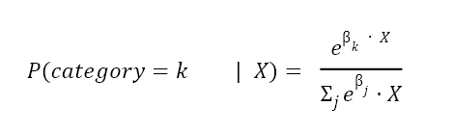
X represents the five input features and βj are the coefficients learned by the model for category k. The model selects the customer segment with the highest probability as the prediction result.

Apply Model to All Commercial Complexes
After training, we applied the MNL model to all 1,033 commercial complexes nationwide. Below are the detailed steps for each complex:
1.Input five consumer profile features
2.Predict customer segment using the trained MNL model
3.Assign product assortment recommendations based on the average series sales share of that customer segment from the 15 pop-up stores
Malls with incomplete feature data were removed to avoid errors. The prediction data was also standardized using the same scale fitted on the training data to ensure training and prediction data are on the same scale.

Product Mix Recommendations
For each mall, after predicting its customer segment, we provided product selection and distribution suggestions based on that group’s average sales share. This assumes that commercial complexes belonging to the same customer segment will have similar consumer purchasing behavior.
The resulting product mix recommendations for each customer segment is shown below.
Product Mix Recommendation for each customer segment
 | Customer Segment | Series Proportion
 |  | 金标 % | 荣耀 % | 国家队 % | 其他 %
0 | 一线城市标杆店 | 16.6% | 31.5% | 0.0% | 51.9%
1 | 女性高消潜力店 | 16.5% | 24.9% | 1.0% | 57.6%
2 | 年轻潮流主力店 | 8.2% | 25.6% | 3.2% | 63.1%

Series Allocation Recommendations
Based on the MNL model predictions, we identified the top 7 highest potential stores for selling the “李宁荣耀金标系列” for Tier 1 and New Tier 1 cities. The results are shown in the tables attached below.
Table 1: Top 7 Stores by “李宁荣耀金标系列” in Tier 1 cities
Rank | Store Name | City | 金标 % | 荣耀 % | 国家队 % | 其他 %
1 | 北京国贸商城 | Beijing | 17% | 32% | 0% | 52%
2 | 上海国金中心 IFC | Shanghai | 16% | 25% | 1% | 58%
3 | 广州天河城 | Guangzhou | 16% | 29% | 0% | 55%
4 | 深圳万象城 | Shenzhen | 16% | 30% | 0% | 54%
5 | 北京 SKP | Beijing | 10% | 32% | 3% | 54%
6 | 上海恒隆广场 | Shanghai | 9% | 17% | 5% | 70%
7 | 上海 IFC 国金中心 | Shanghai | 9% | 17% | 5% | 70%

Table 2: Top 7 Stores by “李宁荣耀金标系列” in New Tier 1 cities
Rank | Store Name | City | 金标 % | 荣耀 % | 国家队 % | 其他 %
1 | 长沙 IFS 国金中心 | Changsha | 12% | 27% | 2% | 60%
2 | 武汉武商广场 | Wuhan | 11% | 30% | 0% | 58%
3 | 南京德基广场（A 馆） | Nanjin | 11% | 26% | 0% | 63%
4 | 沈阳万象城 | Shenyang | 11% | 29% | 0% | 60%
5 | 郑州丹尼斯大卫城 | Zhengzhou | 10% | 28% | 0% | 62%
6 | 杭州万象城 | Hangzhou | 10% | 28% | 2% | 59%
7 | 南京德基广场（B 馆） | Nanjin | 10% | 30% | 2% | 58%
Key Insights
a. Top Tier 1 stores outperform New Tier 1 stores in Gold share. For example, Beijing China World Mall achieves a Gold share of 17%, which is significantly higher than Changsha IFS at 12%.
b. Glory share is consistently high across all top-performing stores. Regardless of whether the store is in a Tier 1 or New Tier 1 city, the Glory share remains strong, ranging from 25% to 32%.
c. National Team share is very low across almost all stores, with shares ranging from 0% to only 5%.
d. Store-level variation is significant, even within the same city. In Shanghai, for instance, Gold share varies considerably from as low as 6% to as high as 16%, depending on the specific commercial complex.Based on the MNL model predictions, we identified the top 7 highest potential stores for selling the “李宁荣耀金标系列” for Tier 1 and New Tier 1 cities. The results are shown in the tables attached below.
Strategic Recommendations
a. We recommend prioritizing the top seven stores in each city tier for pop-up store launches, as these stores show the highest Gold and Glory acceptance based on our model predictions.
b. For the Glory series, all top stores in both city tiers show strong Glory share between 25% and 32%. Therefore, this series is suitable for broad promotion across most core commercial complexes.
c. For the National Team series, we recommend not allocating significant inventory, with a maximum of 0% to 5%, as the demand has proven to be consistently low across almost all store types. However, the National Team series could be piloted in top-tier commercial complexes in Tier 1 cities to test market response, rather than being prioritized for broad pop-up store allocation.
d. For suburban and community malls, the strategy should focus primarily on the Other series, allocating 70% or more of inventory to basic products, while keeping Gold share below 8%.
To facilitate easier access for the business team, we have developed an AI bot that allows users to input natural language queries and generate assortment recommendations for individual commercial complexes.

AI-Assisted Assortment Recommendation System: Implementation and Testing Report
Link for AI bot: https://www.coze.cn/s/v-rkoQAwYeA/

System Background and Objective
In this project, we built an assortment recommendation model for Li-Ning’s new-category stores based on consumer profile data, historical pop-up store sales data, and mall-level characteristics.
The model can evaluate the potential of a commercial complex based on its mall profile and generate recommended allocation shares for different product lines, such as Li-Ning Glory, Li-Ning Glory Gold Label, National Team, and Other Series.
To connect the existing model with AI, our team developed an AI-assisted retail recommendation prototype. Users can upload Excel files and enter natural-language prompts to call the backend model and obtain analysis results.
The system does not allow AI to generate predictions on its own. Instead, AI serves as a natural-language interface.
The numerical calculations are still completed by the backend model. AI mainly understands user questions, triggers the corresponding workflow, and translates model outputs into business-readable conclusions.

Overall System Introduction
The system is implemented using Coze Bot + Coze Workflow + Railway backend + GitHub code management.
In process Description:
(1)The user uploads seven Excel files and enters a natural-language prompt.
(2)Coze Bot understands the user’s intent and triggers the corresponding workflow.
(3)Coze Workflow calls the Railway backend API and passes the uploaded file parameters.
(4)Railway backend receives the HTTP request from the workflow node and calls the Python backend interface deployed on Railway.
(5)Backend computation reads and parses the Excel files, then completes data reading, cleaning, merging, and model calculation.
(6)Result return sends back outputs such as predicted product-line shares for each commercial complex and the TOP20 commercial complex list in JSON format.
(7)Coze Bot output converts the structured model results into language that business users can understand.
In module Functions, Coze Bot provides the user interaction interface, receives uploaded files and natural-language prompts, and triggers the corresponding workflow based on user intent. Coze Workflow receives instructions from the bot, calls the corresponding backend API on Railway, and passes the uploaded file parameters. Railway deploys the Python backend model server and connects with the GitHub repository for automatic deployment. GitHub stores the backend code and connects with Railway for automatic deployment. Python analysis service performs data cleaning, feature engineering, clustering analysis, model prediction, and result output in JSON format. Coze Bot then explains the structured model results in language that business users can understand.
The system does not allow AI to generate predictions on its own. Instead, AI is used as the natural-language interaction layer. AI is responsible for understanding user questions, identifying the task type, triggering the corresponding process, and translating results into business language. The backend model is responsible for data processing and numerical calculation, including clustering and prediction.
This design turns a model that originally could only run in a Notebook into an AI decision-support tool that can be used through a chat interface.

Input File Design
The current prototype requires users to upload seven Excel files.
These files come from the original project data. After splitting and format standardization, they can be read more stably by the workflow.
The seven files are listed below:
File Name | Data Source | Main Purpose
Daily Foot Traffic & Population.xlsx | Consumer profile data | Provides basic features such as city, commercial complex name, working population, and residential population
Mobile Brand TOP Foot Traffic Profile Share.xlsx | Consumer profile data | Provides user shares of phone brands such as Apple, Huawei, Honor, and Xiaomi
Age Share.xlsx | Consumer profile data | Provides age-group shares, used to calculate young customer and mature customer features
Gender Share.xlsx | Consumer profile data | Provides male and female customer ratios
Asset Level Share.xlsx | Consumer profile data | Provides asset-level shares, including ultra-high-net-worth, wealthy, middle-class, well-off, and working-class groups
Updated Pop-up Store Sales Detail_unpivot.xlsx | Pop-up store sales detail data | Provides historical pop-up store sales data by product line, category, sales amount, and sales quantity
Pop-up Store Name Mapping.xlsx | Manually prepared mapping table | Connects historical pop-up store names with standard mall names in the consumer profile data
These seven files can be grouped into three categories.
First, consumer profile data, including population, age, gender, phone brand, and asset level. These files provide input features for the commercial complexes to be predicted.
Second, historical pop-up store sales data, which is used to calculate sales shares by product line and category in historical stores. It provides a reference basis for the model.
Third, the name mapping file, which solves the inconsistency between historical pop-up store names and mall names in the consumer profile data. It ensures that sales data and profile data can be merged correctly.
Technically, one Excel workbook can also contain multiple sheets. However, in the current prototype, we split the original data into seven separate files to improve workflow stability and maintainability.
The current Coze Workflow and Railway backend read files by data module. For example, population data, phone brand data, age data, sales data, and name mapping data each enter different processing steps.
This makes it easier to check whether each type of data has been uploaded completely and to locate data format issues more clearly.

System Workflow
When users operate the system, the process is mainly divided into the following steps.
Step 1: Upload Excel Files
The user uploads the seven standardized Excel files to the Coze Bot.
The system checks whether the required files are complete and passes them to the workflow.
Step 2: Enter a Natural-Language Prompt
The user can enter a natural-language question, such as 'Generate the TOP20 high-potential commercial complexes' or 'Predict the product-line share for Shanghai Nanxiang InCity MEGA'.
The user does not need to understand the backend model structure or write any code.
Step 3: Workflow Identifies the Task Type
Coze Workflow identifies which analysis process should be called based on the user prompt.
User Question | Calling Logic
TOP20 high-potential commercial complexes | Call the TOP20 workflow
Product-line share prediction for all commercial complexes | Call the series workflow
Product-line share prediction for a single mall | Call the series workflow and filter the target mall
Step 4: Backend Model Calculation
The Python backend deployed on Railway reads the uploaded files and performs the following steps:
Read the seven Excel files
↓
Clean column names and data formats
↓
Merge consumer profile data
↓
Process the unpivoted pop-up store sales table
↓
Use the name mapping table to connect historical sales data with mall profiles
↓
Calculate product-line shares and commercial complex potential
↓
Generate TOP20 results or product-line share prediction results
Step 5: AI Generates Business-Level Explanations
After the backend returns structured results, Coze Bot organizes the output into tables and written explanations.

Testing Process
After system debugging was completed, we tested the prototype using the complete set of seven files.

TOP20 High-Potential Commercial Complex Test
The system successfully called the TOP20 workflow and returned the high-potential commercial complex analysis results.
Example of TOP commercial complexes for the Gold Label series in first-tier/ new first-tier cities:
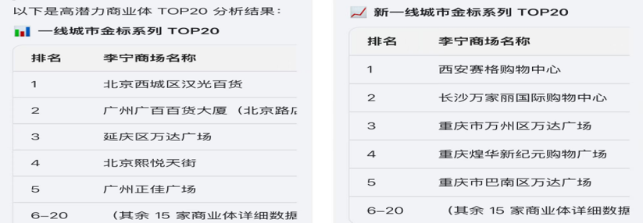
The test output showed that Xi’an SEG Shopping Center had the highest national potential, with a predicted Gold Label share of 60.68%.
Among first-tier cities, Beijing Xicheng Hanguang Department Store ranked first in Gold Label share, at 52.15%.
Among new first-tier cities, Chongqing, Changsha, and Xi’an showed strong performance and accounted for a large share of the TOP20 list.
The National Team series generally had a low predicted share, with the highest being Guangzhou Grandview Mall at 17.82%.

Single-Store Product-Line Share Prediction Test
In the output analysis, the Glory series share exceeded 60%, making it the core sales category for this mall. This is consistent with the characteristics of a young trend-driven store.
The Gold Label series share was close to 30%, higher than the Shanghai regional average of 27.8%, indicating relatively strong acceptance of premium products.
The National Team series share reached 9.42%, significantly higher than the average level of 1.68% for benchmark first-tier city stores. This suggests that consumers in this mall have stronger demand for professional sports products.
Comparison with similar malls in the Shanghai region:
Mall Name | Gold Share | Glory Share | National Team Share
Shanghai Nanxiang InCity MEGA | 29.11% | 61.47% | 9.42%
Shanghai Changning Cloud Nine Shopping Mall | 28.66% | 63.40% | 7.93%
Shanghai Minhang Qibao Vanke Plaza | 29.57% | 61.22% | 9.20%
Shanghai Global Harbor | 33.64% | 55.71% | 10.64%
For assortment recommendations, the store should prioritize sufficient inventory for the Glory series, especially popular styles and key sizes, to maintain its core sales advantage.
The store should also increase the display of the Gold Label series. Given its relatively high acceptance, the store can expand shelf space and promotion efforts for premium products.
For the National Team series, the store should optimize its product structure, focus on professional sports categories, and introduce more targeted marketing activities to further improve its share.

Summary
This section completed the prototype development for integrating the Li-Ning assortment recommendation model with an AI tool.
The system uses Coze Bot to provide a natural-language interaction interface, Coze Workflow to identify user tasks, and a Python backend deployed on Railway to complete model calculation. AI then organizes the results into business-readable output.
The test results show that, after uploading the seven standardized Excel files, users can enter “Generate the TOP20 high-potential commercial complexes,” and the system can successfully return high-potential Gold Label commercial complexes in first-tier and new first-tier cities.
This confirms that the system has completed the full process from data upload, prompt recognition, workflow calling, and model calculation to AI output.
Compared with the original Notebook version, this AI-assisted system has the following advantages:
(1)It lowers the usage barrier. Business users do not need to understand Python code, model parameters, or data processing logic. They only need to upload files and enter questions.
(2)It improves interactivity. Users can ask questions in natural language, and the system can call different workflows based on different prompts.
(3)It improves model interpretability. Model outputs are no longer just data tables; they can be translated by AI into business language.

Future Optimization Directions
(1)The seven files can be integrated into one standardized input workbook to reduce the upload burden for users.
(2)The system can support more complete result downloads, such as exporting the full TOP20 Excel file, the product-line share prediction table for all commercial complexes, and single-mall analysis reports.
(3)Exact search based on Winshang Project ID can be added to avoid matching issues caused by mall aliases and chain-mall names.
(4)Risk warnings can be further strengthened, such as flagging missing data, out-of-sample commercial complexes, uncertain name matching, and low prediction confidence.

Modeling

Method Overview
The core output has been changed to: Based on the mall profile, identify whether this new store is more likely to be "shoe-driven", "apparel-driven", or "accessories-driven", "prestige-driven", "gold label-driven", "national team-driven", or "other types", and provide a suggested range of high/medium/low proportions, rather than a specific percentage.
Level | Dependent variable (Y)
First layer: Major product category structure | Y₁ Footwear percentage / Y₂ Apparel percentage / Y₃ Accessories percentage
Second layer: Product line allocation | Y₄ Li-Ning Glory percentage / Y₅ Other series percentage / Y₆ Li-Ning Glory Gold Label percentage
Supplementary quality indicators | Y₇ Tag fulfillment rate (auxiliary validation, Beta regression or OLS)

Product selection risk assessment tool: Store type identification and category classification range

Objective
The objective of this project is to classify new stores into different store types based on historical data from pop-up stores and to provide recommended category mix ranges for each type. The objectives of Module B are as follows:
(1) Identify naturally formed category structure types for stores;
(2) Estimate the category mix ranges for each type;
(3)Use OLS and Ridge regression to perform auxiliary validation on key feature directions, providing support for subsequent scorecard development.

Data Processing and Analysis Methods
This study uses 15 Li-Ning stores as its sample. Based on sales data, three core metrics were first established: the proportion of footwear, the proportion of apparel, and the proportion of accessories.
Since total sales volumes vary significantly across stores, this section uses sales proportions for analysis to better reflect each store’s product selection and ensure comparability between stores.
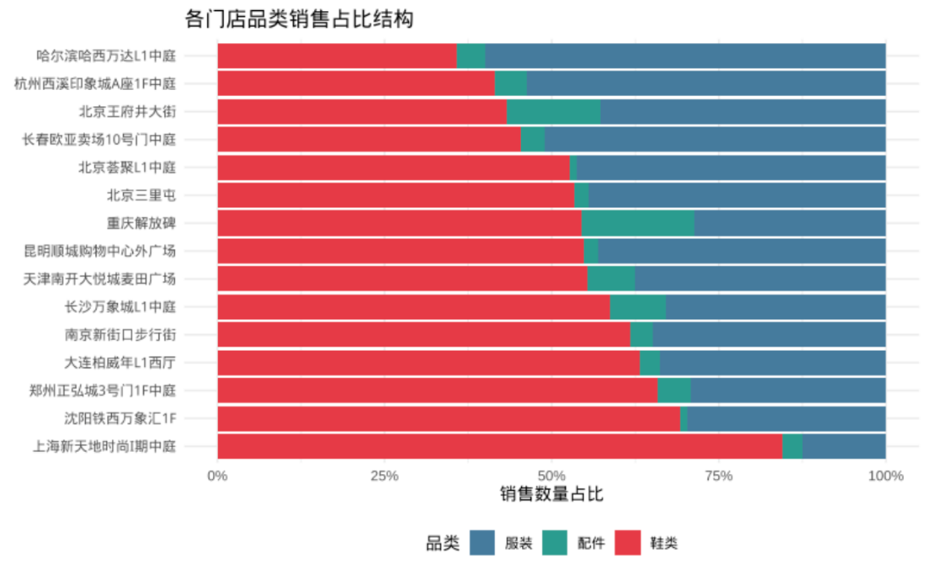
Next, we used K-Means clustering to identify store types and compared the results for k=2, k=3, and k=4. Then, we calculated the mean and standard deviation of the proportions of footwear, apparel, and accessories for each type, and constructed a recommended range using “mean ± 1SD.” Finally, we will combine these store type classifications with mall feature variables to create a “Type × Feature” profiling table, and use OLS and Ridge regression to validate the trends in the proportions of footwear and accessories.
Furthermore, to avoid conflating “category structure” with “operational quality,” this study did not include the tag realization rate (Y₇) as a clustering variable; instead, it was treated as a supplementary indicator in subsequent analyses to identify differences in operational performance within stores of the same type. This approach preserves the purity of the store type labels, allowing them to focus on reflecting category structure characteristics, while introducing a quality dimension in subsequent scorecards to complement the analysis.

Store Type Identification Results
Elbow Method：
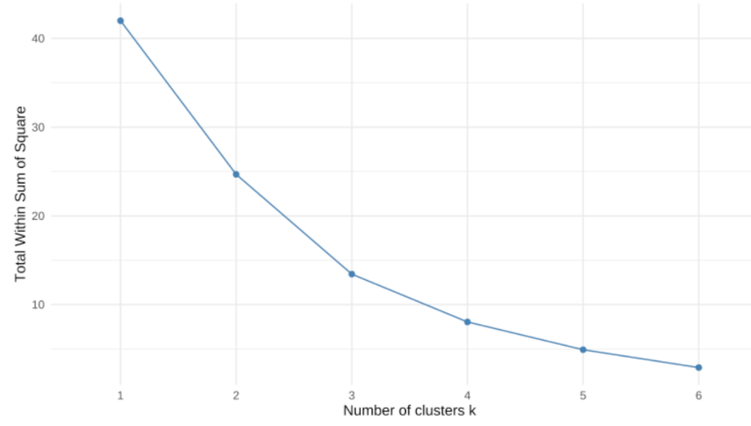
Silhouette Score：
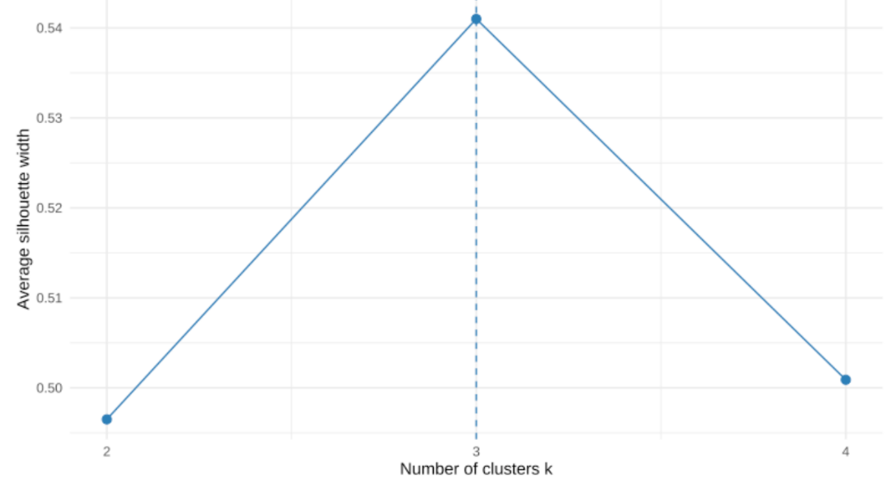
Contour coefficient comparison:
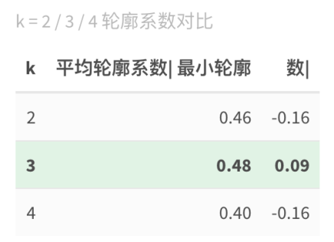
Based on the comparison of the Elbow Method and the Silhouette Score, k=3 was ultimately selected as the optimal number of clusters.
Although the Elbow plot indicates that both k=2 and k=3 are reasonable candidates, in a formal comparison of k=2, 3, and 4, k=3 yielded the highest average silhouette coefficient; therefore, a three-cluster classification scheme was ultimately adopted.
Clustering visualization:
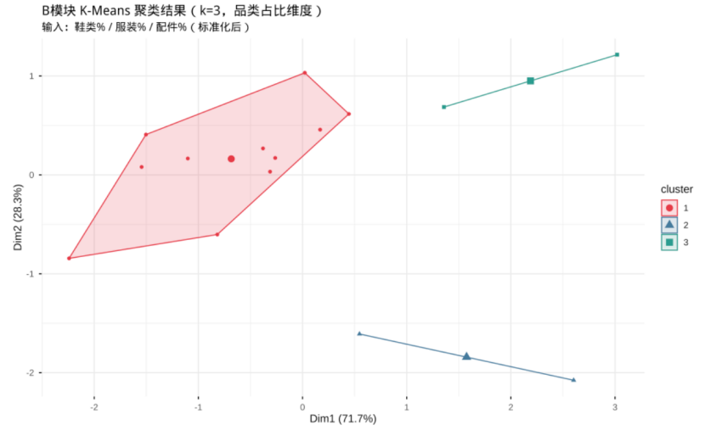
According to the clustering results, the 15 stores can be divided into three categories.
(1) Shoe-driven Type
This category of stores has the highest average proportion of footwear, at approximately 66.0%, while apparel accounts for about 33.3% and accessories only about 0.7%. This indicates that the sales structure of these stores is clearly dominated by footwear.
(2) Balanced Type
In this category, footwear accounts for an average of approximately 52.8%, while apparel accounts for approximately 44.2%. As the proportions of the two are relatively close, the overall structure is more balanced.
(3) Accessories/Apparel Specialized Type
In this category, footwear accounts for an average of approximately 40.9%, apparel accounts for approximately 58.2%, and accessories account for approximately 0.9%.
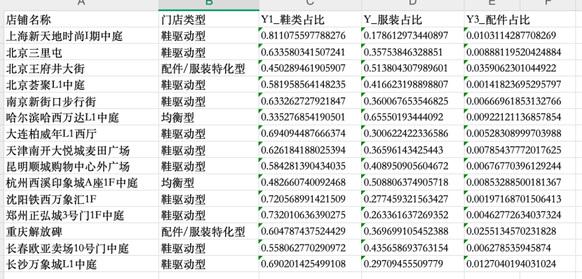
In terms of sample size, there were 11 shoe-focused stores, 2 balanced stores, and 2 stores specializing in accessories and apparel.
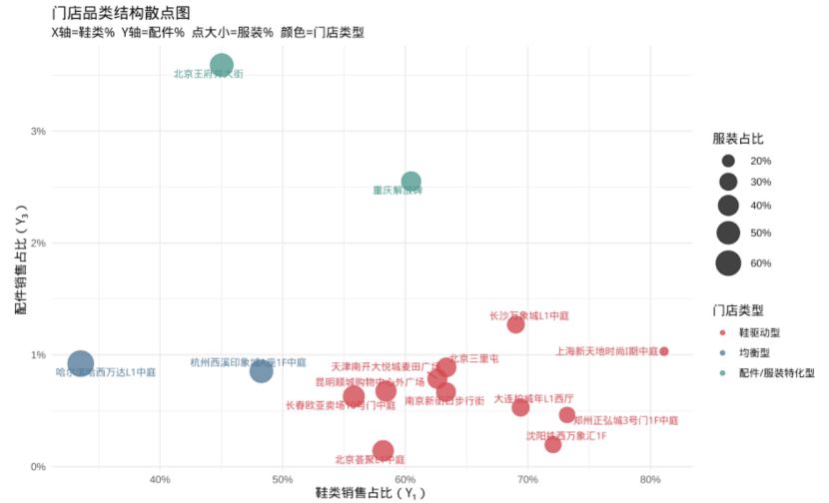
By plotting the proportion of footwear on the x-axis, the proportion of accessories on the y-axis, and using the proportion of apparel to determine the size of the data points, we visualized the product category structure of 15 stores. The results show that footwear-driven stores are primarily concentrated in the region with a high proportion of footwear and a low proportion of accessories, indicating that their sales structure is clearly dominated by footwear; balanced stores have a relatively lower proportion of footwear but larger data points, suggesting a higher proportion of apparel and a more balanced overall structure; The third category, apparel-specialized stores, is characterized by a low proportion of footwear and significantly higher proportions of accessories and apparel. This chart visually confirms the differences in category structure among the three store types, supporting subsequent estimation of type-specific proportion ranges. This indicates that the footwear-driven model is the most common store structure in the sample, while the other two categories, although represented by a smaller sample size, still exhibit distinct characteristics.

Category Proportioning Range Results
After classifying the stores by type, calculate the mean and standard deviation of the proportions of footwear, apparel, and accessories within each category, and use the range “mean ± 1SD” to describe the fluctuation range of stores in that category within the historical sample.
(1) Shoe-driven Type
The recommended range for footwear is 58.4%–73.7%, for apparel 25.6%–41.0%, and for accessories 0.3%–1.0%.
(2) Balanced Type
The recommended range for footwear is 30.5%–51.3%, for apparel 47.8%–68.6%, and 0.8%–0.9% for accessories.
(3) Accessories/Apparel Specialized Type
The recommended range for footwear is 41.8%–63.7%, for apparel is 34.0%–54.4%, and for accessories is 2.3%–3.8%.
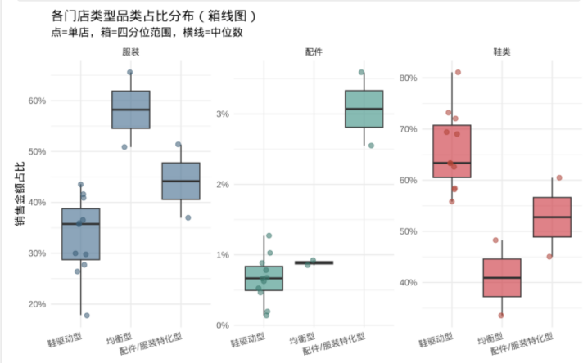
The results indicate clear differences in product assortment structures across different store types. Even at the lower end of the range, footwear accounts for nearly 60% of the product mix in footwear-driven stores, demonstrating the stability of their core characteristics. The proportion of apparel is significantly higher in balanced stores, suggesting that this store type cannot simply adopt the product mix of footwear-driven stores. In apparel-specialized stores, accessories account for a higher proportion than in the other two categories, indicating that accessories can play a more prominent supporting role in these stores.

Type × Feature Profiling Results
To support the subsequent development of a scoring card, this study further analyzed differences in mall characteristics across different store types, resulting in a “Type × Characteristic” profile table. Key characteristics included the proportion of Apple stores, purchasing power index, foot traffic proxy, overall discount rate, proportion of male customers, youth customer index, city tier, and average weekly sales. The results indicate that significant differences exist across multiple dimensions among different store types:
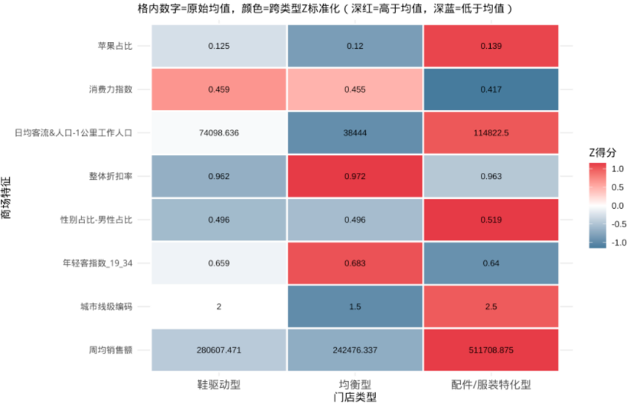
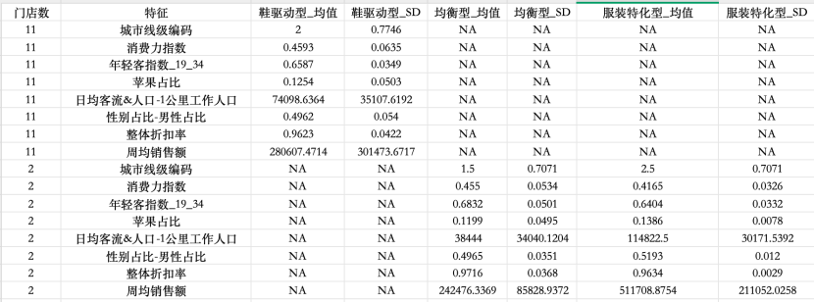
(1) Shoe-Driven Type
These stores are located in upper-middle-tier cities, have a high purchasing power index, a strong customer base, and high average weekly sales. Overall, they are more akin to stores characterized by “broad mass appeal and a focus on footwear.”
(2) Balanced Type
This category of stores has the highest youth customer index and the highest overall discount rate, indicating a younger customer base with a stronger demand for apparel and relatively higher price tolerance.
(3) Accessories/Apparel Specialized Type
This category of stores has a high proportion of Apple products, high city tier, strong foot traffic, and high average weekly sales, indicating that they are more likely to be found in high-tier commercial districts with high foot traffic and stronger commercial potential.
From the perspective of the scorecard, variables such as city tier, proportion of Apple products, foot traffic, and the young customer index can serve as important inputs for the subsequent D module to determine which store type a new store most closely resembles.

OLS / Ridge Orientation Verification Results
This module examines whether the direction of the effects of different features in OLS and Ridge regression aligns with the cluster profiles. Using the proportion of footwear (Y1) and the proportion of accessories (Y3) as dependent variables, we compare the directions of the coefficients between OLS and Ridge regression.
The results show that the direction of the effects exhibits characteristics of “partial consistency and partial inconsistency.”
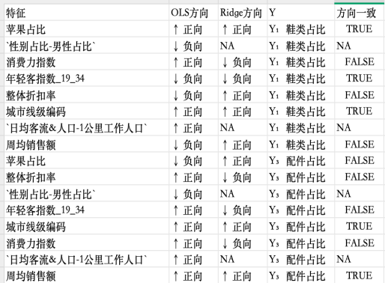
For the footwear share (Y1), the Apple user share, city tier, and youth customer index show consistent trends across both OLS and Ridge models. Specifically, both the Apple user share and city tier are positively correlated, indicating that higher-tier malls and stores with a higher proportion of Apple users are more likely to develop a footwear-driven structure; the youth customer index is negatively correlated, suggesting that a younger customer base does not necessarily correspond to a higher footwear share.
For the accessory share (Y3), the direction of city tier and weekly average sales is consistent between OLS and Ridge, indicating that stores in higher-tier cities with higher sales volumes are more likely to have a higher accessory share.
At the same time, some variables show conflicting directions, such as the overall discount rate. This suggests that, given the current small sample size of 15 stores, the independent effects of certain variables are unstable and may be influenced by factors such as insufficient sample size, multicollinearity, and an uneven distribution of store types.

Module Conclusion
Overall, Module B conducted store classification, interval estimation, and directional validation. First, K-Means clustering was performed based on the sales proportions of footwear, apparel, and accessories across 15 stores, with (k=3) ultimately selected as the optimal number of clusters. The clustering results indicate that the sample stores can be divided into three categories: footwear-driven, balanced, and accessories/apparel-specialized. Among these, the footwear-driven stores were the most numerous, totaling 11, and represented the most common store structure in the sample; there were 2 balanced-type and 2 accessories/apparel-specialized stores each, with a smaller sample size and distinct differences in category structure. Second, this study constructed a recommended range for category allocation of “mean ± 1SD” based on the mean and standard deviation within each type. There is a clear distinction in the product selection structure: Shoe-driven stores have the highest proportion of footwear, with a stable core sales structure dominated by footwear; balanced stores show a significantly higher proportion of apparel, indicating that their assortment strategy cannot simply replicate that of shoe-driven stores; accessory/apparel-specialized stores exhibit an even higher proportion of apparel. Module B provides directly applicable category boundaries and proportion ranges for subsequent scoring tools.
In the “Type × Feature” profiling analysis, different store types exhibit significant differences across dimensions such as city tier, Apple product share, foot traffic proxy,
youth customer index, and average weekly sales. Directional validation results from OLS and Ridge regression
indicate that the direction of some features is relatively stable, such as the relationship between Apple product share, city tier, and youth customer index, as well as city tier and weekly average sales in the accessories share; however, some variables exhibit conflicting directions, indicating that under the current small sample size of 15 stores, the independent effects of certain features are unstable.
Given the current sample conditions, Li-Ning stores are better suited to adopt a “tiered assessment + interval recommendation” approach for product selection risk
classification, rather than making point predictions directly on individual store category shares.
A limitation of this study is that the component data were not subjected to a rigorous CoDA transformation. In future studies with a larger sample size, the use of log-ratio transformations combined with clustering methods could be considered to further enhance the theoretical rigor and stability of the model.

Product selection risk grading tool: Product line grading mapping and feature association
File: lining_C_risk_tool.Rmd

Objective
This module aims to identify the product line preferences of stores, establish product line allocation ranges for different price tiers, and explore the relationship between mall characteristics and product line allocation. Specific objectives are as follows:
(1) Based on the store classification in Module B, establish a mapping relationship of "store type → product line ratio range";
(2) Perform independent clustering of product lines and examine their overlap with category classification;
(3) Discover significant features through nonparametric correlation analysis (Spearman) and output qualitative interpretation and linkage rules in combination with business scenarios.
B-type / C-type | Honor-dominant type | Gold Standard Dominant | balancedtype | Remark
Shoe-driven (11 companies) | 6Home | 2Home | 3Home | As the absolute mainstay of the shoe-driven market (11 companies), there is a clear differentiation in their product lines: 6 companies are dominated by Honor, 2 companies are dominated by Gold Label, and 3 companies are balanced.
Clothing-focused (2 families) | 0 | 2 | 0 | The two stores specializing in apparel are 100% aligned with the Gold Label-dominated model. This indicates that as long as a store's core business is apparel sales, its underlying core support is highly likely to be the Li-Ning Glory Gold Label series, and the two are closely intertwined in terms of business logic.
Balanced type (2 companies) | 0 | 0 | 2 | The two balanced stores also perfectly reflect the balanced product line.
total | 6 | 4 | 5
Overlap between B and C fractals
The overlap between Category B (major category) and Category C (product line) is approximately 53% (8 out of 15 stores are consistent), indicating that the two dimensions do indeed capture store characteristics at different levels. Module C provides incremental information beyond that of Module B.。

Data Processing and Variable Definition
This module takes over the previous sales details data. To ensure cross-store comparability, it uses the total sales amount of the store as the benchmark to calculate four core product line indicators: the proportion of national team (Y₄), the proportion of Li-Ning Glory Gold Label (Y₅), the proportion of Li-Ning Glory (Y₆), and the proportion of other series (Y₇, i.e., 1 - Y₄ - Y₅ - Y₆).
Preliminary data analysis reveals significant differences in penetration rates across different stores for core product lines. For instance, the Li-Ning Glory brand has a high penetration rate (approximately 28.9%), Li-Ning Glory Gold Label brand (approximately 11.6%), and National Team brand (approximately 2.4%) at the Wangfujing Street store in Beijing. The Li-Ning Glory Gold Label brand at the outdoor plaza of Kunming Shuncheng Shopping Center reaches approximately 29.6%, while the Li-Ning Glory brand penetration rate at the L1 atrium of Harbin Haxi Wanda Plaza is as high as approximately 60.2%. In contrast, some stores (such as Nanjing Xinjiekou and Dalian Parkson) currently have a National Team penetration rate of 0. This naturally occurring structural difference provides a reliable data foundation for subsequently constructing a product line tiered mapping system.
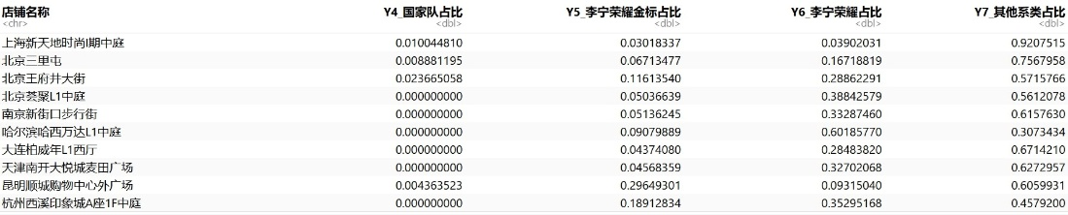

Mapping of Store Type and Product Line Ratio Range
After determining the product category structure of the stores (Module B), this module further calculated the mean and standard deviation of each store type on the core product lines (National Team, Li-Ning Glory Gold Label, Li-Ning Glory, and other series), and constructed a suggested range for product line allocation using "mean ± 1SD". This mapping table, as a core deliverable, can be directly written into the underlying rules of the grading tool.
Based on the output results, the three types of stores exhibit clear differences in product line distribution:
(1) Shoe-driven (11 companies)
The recommended range for the national team is 0%–1%, for Li-Ning Glory Gold Label it is 1%–17%, for Li-Ning Glory it is 12%–34%, and for other series it is 57%–79%.
As the most mainstream store type in the sample, the National Team series accounted for a very low proportion, the Gold Label series accounted for a relatively limited proportion (up to 17%), while the Li-Ning Glory series occupied a significant share (down to 12% and up to 34%). This indicates that in footwear-dominated stores, the Glory series is an indispensable performance driver, and its proportion can be flexibly adjusted between 12% and 34% depending on the characteristics of the business district, while the Gold Label series serves as a distinctive supplement.
(2) Balanced type (2 companies)
The recommended range for the national team is 0%–0%, for Li-Ning Glory Gold Label it is 7%–21%, for Li-Ning Glory it is 30%–65%, and for other series it is 28%–49%.
Historically, these stores have almost no sales of the national team series, but the Li-Ning Glory series has achieved absolute dominance (30%–65%), while the Gold Label series has also maintained a relatively high level of 7%–21%. This indicates that in stores with a relatively balanced apparel and footwear structure, the Glory series, with its broader audience base, is the core driving force and has a very high necessity for distribution, while the Gold Label series can further enrich the product range.
(3) Accessories/Clothing Specialty Products (2 companies)
The recommended range for the national team is 1%–3%, for Li-Ning Glory Gold Label it is 8%–12%, for Li-Ning Glory it is 18%–31%, and for other series it is 54%–73%.
This type of store is the only one among the three categories with a significant and stable proportion of the "National Team" series (1%–3%), while the "Honorary" series (18%–31%) and "Gold Label" series (8%–12%) also remain at stable levels. Combined with their "high-tier, high-traffic" profile, this indicates that in commercially viable areas, the "National Team" series can effectively supplement and enhance the store's image and cross-selling potential.

Product Line Independent Clustering Validation
To examine whether the product line classification highly overlaps with the category classification in Module B, this module conducted an independent K-Means cluster analysis using the three-dimensional indicators of the proportion of national team (Y₄), the proportion of Li-Ning Glory Gold Label (Y₅), and the proportion of other series (Y₆) as inputs.
Optimal number of clusters selection
According to the WSS (within-group sum of squared errors) curve of the Elbow Method, the downward slope of the curve slows down when k=3. Considering the richness of business interpretation and the correspondence with the three-category classification of Module B, k=3 was ultimately chosen as the optimal number of clusters.
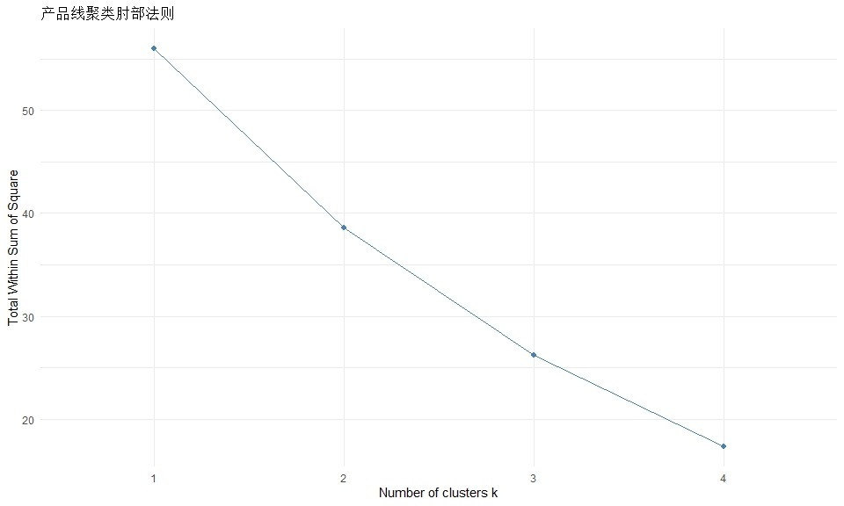
Clustering Results and Visualization
With k=3, the clustering results divided the 15 stores into three product line preference types. The clustering visualization (PCA dimensionality reduction) shows that the three types of stores form relatively clear clusters in two-dimensional space.
Cluster 1 (red area): Includes 6 stores such as Nanjing Xinjiekou Pedestrian Street and Beijing IKEA L1 Atrium.
Cluster 2 (Green Area): Includes 4 stores such as the outer plaza of Kunming Shuncheng Shopping Center and the atrium of Gate 10 of Changrui Eurasia Mall.
Cluster 3 (blue area): Includes 5 stores such as the one on Wangfujing Street in Beijing and the one in Jiefangbei in Chongqing. These stores also form a separate cluster in the map.
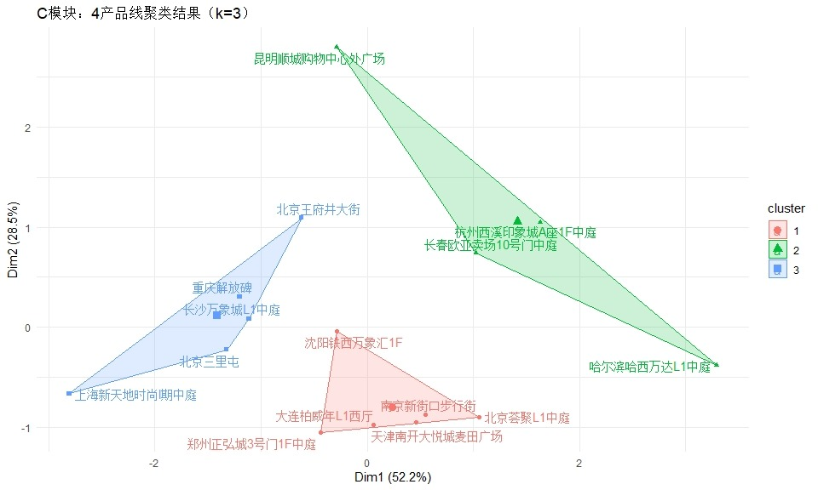
Overlap analysis with Module B
By constructing a cross-tabulation of the category classification in module B and the product line classification in module C, this study further examined the overlap between the two classification systems. The results show that there is some overlap between the two classification levels, but they are not highly identical.
B-type / C-type | Honor-dominant type | Gold Standard Dominant | Balanced
Shoe-driven 11 | 6 | 2 | 3
Clothing-focused 2 | 0 | 2 | 0
Balanced type 2 | 0 | 0 | 2

Feature Correlation Analysis
To further explore the impact of shopping mall characteristics on product line allocation, this module employs Spearman correlation analysis (a non-parametric method suitable for small samples n=15) to screen for significant features with absolute correlation coefficients greater than 0.4 to the proportion of each core product line. Introducing more granular customer profile features reveals a close yet differentiated relationship between product line preferences and the store's category structure and the characteristics of the customer base within the shopping district.
(1) Distinctive features of Li-Ning Glory Series (Y₆)
Correlation with customer groups in the business district: The proportion of Honor phones was significantly positively correlated with the proportion of customers aged 30-34 (r = 0.64), the proportion of customers using Huawei phones (r = 0.61), and the proportion of customers aged 40-44 (r = 0.51); it was moderately negatively correlated with the working population within 1 kilometer (r = -0.45); and it was moderately negatively correlated with the proportion of males (r = -0.40).
(2) Distinctive features of Li-Ning Glory Gold Label Series (Y₅)
Correlation with the customer base of the business district: The proportion of gold-label customers is negatively correlated with the proportion of male customers (r = -0.40), indicating that it performs relatively better in business districts with a higher proportion of female customers.
(3) Significant features of the national team series (Y₄)
Correlation with the customer base of the business district: The proportion of national team members was significantly positively correlated with the proportion of Apple mobile phone users (r = 0.58), the proportion of salaried asset class users (r = 0.52), the working population within 1 kilometer (r = 0.48), the city tier (r = 0.48), and the proportion of male users (r = 0.44); and significantly negatively correlated with the proportion of 30-34 year olds (r = -0.56), the proportion of middle-class asset class users (r = -0.53), the proportion of 40-44 year olds (r = -0.48), and the proportion of Huawei mobile phone users (r = -0.42).
(4) Inter-product line linkage rules
Negative correlation: The analysis results show that there is a very strong negative correlation between the proportion of the national team (Y₄) and the proportion of Li Ning Glory (Y₆) (r = -0.65).
Application Rules for the Tool: In tiered tools, the proportions of each series should not be predicted as completely independent values. When the proportion of the National Team series is increased based on business district characteristics (such as high customer traffic for Apple products or higher-tier markets), the expected proportion of the Li-Ning Glory series should be adjusted downward accordingly, and vice versa. This linkage rule ensures the logical consistency of the overall product line proportions.
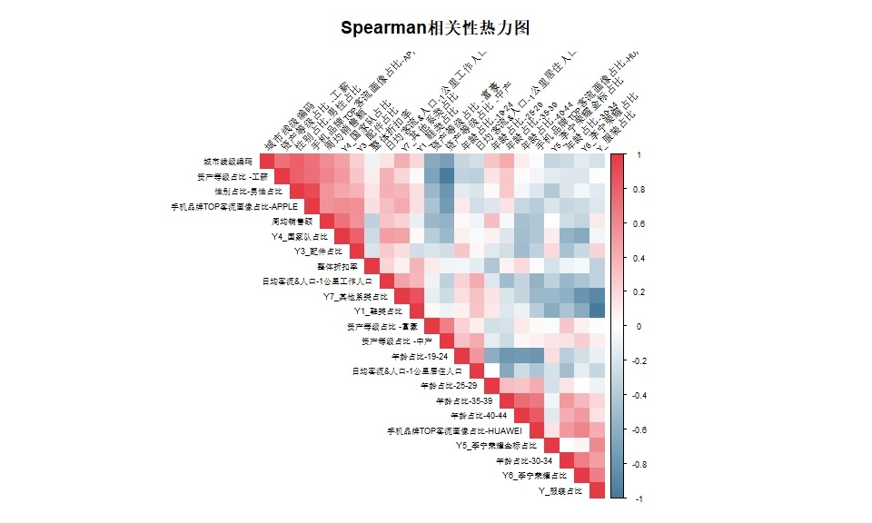

Business Interpretation
(1) Shift in core logic perspective: from "accurate prediction" to "tiered management and control"
Given the limited sample size of historical pop-up stores (n=15), this tool successfully shifted the business objective from "point prediction of single-store category proportion" to "risk grading and interval suggestions based on store type." By constructing a two-dimensional scoring system of "major category structure (Module B) + subdivided product lines (Module C)," we not only avoided the overfitting risk of small-sample regression but also provided quantitative guidance for new store product selection that combines scientific boundaries with flexible adjustment space.
(2) The three-legged balance of the store ecosystem and the strategic positioning of the product line
The data reveals three distinct structures within the current store ecosystem and clarifies the strategic focus for each core product line:
Shoe-driven (basic):The vast majority (11 stores) are footwear stores. In these core stores, the Li-Ning Glory series (12%–34%) is an indispensable pillar of performance, the Gold Label series (1%–17%) serves as a distinctive supplement, and the National Team series is almost never featured.
Balanced type (Honor's main base):Footwear and apparel are evenly distributed. These stores are the absolute dominant force for Li-Ning's Glory series (accounting for 30%–65%), while the Gold Label series also maintains a high level (7%–21%). This indicates that when the apparel category gains momentum, the Glory series has extremely strong explosive power and is essential for widespread distribution.
Specialized accessories/clothing (high-energy display window):Located in prime commercial areas with high customer traffic and a high percentage of Apple users, these stores not only have a high accessory sales rate, but also hold a dominant position for national team products (1%–3%), serving as a showcase for enhancing brand image and reaching high-net-worth customers.
(3) Precise mapping rules driven by business district characteristics
Through nonparametric correlation analysis, the tool identified the core driving factors behind different product lines:
Li-Ning Glory Series (Y₆):The product line is highly dependent on apparel sales. In terms of customer demographics, this series demonstrates strong penetration in shopping districts with a high proportion of mature consumers aged 30-44 and Huawei phone users. It is recommended that in stores matching these customer characteristics and where apparel constitutes a significant portion of the merchandise, the proportion of the Honor series should be appropriately tilted towards the upper end of this range.
Gold Label Series (Y₅):Also driven by the apparel category, and performing better in shopping districts with a high proportion of female customers, it can serve as an effective complement to the Honor series.
National Team Series (Y₄):Possessing strong attributes of "high potential and large customer flow," the National Team series complements the target customer profile of the Honor series. In shopping malls located in high-tier cities with dense surrounding working populations, large overall sales volume, and a customer base leaning towards Apple phone users, men, and salaried workers, the National Team series performs better, often accompanied by a high rate of accessory sales. It is recommended to ensure stable exposure of the National Team series in high-traffic, high-tier core business district stores.

Execution Summary
Based on the output results of Module B (K-Means clustering for major product categories) and Module C (product line clustering + Spearman association analysis), combined with the original pop-up store sales data, consumer profile data and V12 commercial entity data, an operational new product category store product selection and grading scoring tool was constructed.
The core objective of the tool is to allow Li Ning's team to input six characteristics of a new shopping mall before opening a store, and within five minutes obtain a reference range for "which segment it belongs to, the recommended proportion of shoes/apparel/accessories, the recommended proportion of Honor/Gold Label/other product lines," as well as corresponding risk warnings.
Key findings
• The rating card divides the new shopping mall into three tiers: high-end (dominated by Honor), balanced, and mass-market (dominated by other series), with each tier corresponding to a different range of recommended product selection ratios.
• The quality filter was adjusted from Y7≥0.95 to Y7≥0.90, and the number of qualified reference stores was expanded from 6 to 14. The performance of the K-NN similar store search model has been significantly improved, and it has outperformed the scoring system in both the apparel and honor dimensions.
• The only statistically significant customer profile drivers for the Honor series (Y6) are: average daily customer traffic (r=0.574**), the proportion of customers aged 30-44 (r=0.625**), and the proportion of Huawei phones used (r=0.561**). It is worth noting that the main customer group driving Honor's sales is the mature 30-44 age group, rather than the 19-34 age group defined by the brand.
• The correlation between the Gold Label series (Y5) and all profile features is below 0.40. The driving factors are at the level of display location and sales guidance strategy, which cannot be captured by the current dataset. The Gold Label allocation ratio is recommended to have the lowest confidence and should be dynamically adjusted after opening.
• The GBM point prediction error for accessories is LOO-MAE=0.70pp, which is the smallest error among the 6 categories and can be used as a reference for the magnitude.

Methodological Framework

Overall Logic
The core problem of module D is: given the characteristics of a new shopping mall, how to recommend a reasonable product selection ratio? The tool adopts a two-step progressive approach:
• Step 1 (Scoring Card): Convert the six profile features of the new shopping mall into a comprehensive score between 1.00 and 3.00, and divide them into three levels (high-end/balanced/mass-market) based on the tertiary threshold. The scoring card is a simplified tool suitable for quick assessment.
• The second step (K-NN similar store search): Find the historical stores most similar to the new shopping mall in the feature space, directly using the proportion data of these similar stores as a reference. K-NN is the core method, which does not rely on manual threshold segmentation and has more rigorous logic.
The two methods are used in parallel. When the two methods reach the same conclusion, the result can be adopted with confidence. When the two methods differ, the result of K-NN shall prevail and manual review shall be triggered.

Prerequisite: Quality Filtration
Historical store mix data reflects "what actually happened," not "what should have been done." If a historical store is having a large-scale clearance sale, its mix structure is unreliable and should not be used as a reference.
Filtering criteria: Tag fulfillment rate Y7 (actual sales revenue ÷ tag price sales revenue) ≥ 0.90, meaning at least 90% of the goods are sold at full price. A low Y7 indicates a mismatch between the sales volume and customer demand, resulting in unsold inventory being cleared out through discounts. Currently, among the 15 stores, only Sanlitun in Beijing (Y7=0.842) does not meet the criteria, and the remaining 14 stores are in the K-NN candidate pool.

Scoring Card Design: D. Method for Generating the Total Score

Six scoring dimensions and their weights
The scoring card selects 6 mall profile features as scoring dimensions. Each feature is divided into three levels: high, medium, and low based on the ternary values of the historical data of 15 stores, and scores 3, 2, and 1 points respectively. After multiplying by the weights, the scores are summed to obtain a comprehensive score (D total score) between 1.00 and 3.00.
Weights are determined by combining the direction of the coefficients from the OLS/Ridge regression in Module B (which reflects which features can distinguish the structural types of major categories) and the Spearman correlation coefficients in Module C (which reflects which features are related to the proportion of product lines), and then adjusting them based on business judgments.
Serial Number | Rating Dimensions | Weight | High-end → 3 points | Mid-range → 2 points | Low grade → 1 point | Weight setting basis
① | Consumer spending power index  (5 millionaires + 3 middle-class + 2 well-off) | 25% | ≥ 2.144 | 1.929–2.144 | < 1.929 | Module B's OLS coefficients are aligned in the same direction; Module C focuses on the core drivers of consumer quality across each product line; the highest weight reflects that product selection quality takes precedence over scale.
② | Young customer index (total percentage of customers aged 19–34) | 20% | ≥ 0.657 | 0.641–0.657 | < 0.641 | The direct definition of the target customer group for the Honor series; the Spearman data signal is weak (r=0.08), but the business logic is strong, so it retains a high weight.
③ | Apple iPhone market share | 20% | ≥ 13.4% | 10.2%–13.4% | < 10.2% | This serves as a proxy indicator for consumer willingness and purchasing power; complementing the consumer spending power index, together they cover 45% of the "whether one has money and is willing to spend" factor.
④ | Average daily customer traffic at the shopping mall (February 2026) | 15% | ≥ 51,543 | 43,801–51,543 | < 43,801 | Module C has the only statistically significant feature (r=0.574**); however, it measures scale rather than quality, so the weighting was proactively lowered to 15% to prevent the rating from being dominated by customer flow.
⑤ | City-level tiers (first-tier = 4, strong second-tier = 3...) | 10% | First-tier (≥ 3.5) | Strong second-tier (2.5–3.5) | Second-tier and below (< 2.5) | Module B's OLS direction is stable and positive; macro-anchored variables; the 15 sample companies are mainly first-tier/strong second-tier cities, with limited differentiation, so 10% is reasonable.
⑥ | High-end competitors exist  (Archaeopteryx/KOLON/lululemon) | 10% | Yes (=1) | — | None (=0) | 0/1 is a binary variable, inherently with low distinguishability; the presence of high-end competitors indicates that the overall positioning of the business district is high-end, retaining only supplementary reference value.

Calculation Steps (Taking Zhengzhou Zhenghong City as an Example)
The following shows the complete scoring calculation process for Zhengzhou Zhenghong City, making it easier to understand the logic behind generating the D total score:
Serial Number | feature | Weight | actual value | Gear determination | Score × Weight | Judgment Explanation
① | Consumer spending power index | 25% | 2.32 | upscale | 3 × 25% = 0.75 | 2.32 ≥ 2.144, High-end
② | Young Customer Index | 20% | 0.712 | upscale | 3 × 20% = 0.60 | 0.712 ≥ 0.657, high-end
③ | Apple iPhone market share | 20% | 13.2% | Mid-range | 2 × 20% = 0.40 | 10.2% ≤ 13.2% < 13.4%, mid-range
④ | Daily passenger flow | 15% | 54,294 | upscale | 3 × 15% = 0.45 | 54,294 ≥ 51,543, High-end
⑤ | City Line | 10% | 3 (Strong Second Tier) | Mid-range | 2 × 10% = 0.20 | 2.5 ≤ 3 < 3.5, strong second-tier mid-range
⑥ | High-end competitors | 10% | have | upscale | 3 × 10% = 0.30 | There are high-end competitors, high-end...
total |  | 100% |  |  | 0.75+0.60+0.40+0.45+0.20+0.30 = 2.70
in conclusion | Zhengzhou Zhenghong City D Total Score = 2.70 ≥ 2.17 → Classified as High-end (Glory-dominated) Tier

Classification Rules for D Gear
After the total score is calculated, the stores are divided into tiers based on the third-place rank of the historical total score distribution across the 15 stores: the upper third rank is approximately 2.17, and the lower third rank is approximately 1.90. This design ensures that each tier has sufficient historical samples to support the recommended allocation range.
Gear name | Total score range | Historical store count | Sample stores | Business District Positioning Characteristics | Gear naming logic
High-end  (Honor-led) | ≥ 2.17 | 5 companies | Zhengzhou, Tianjin, Harbin  Nanjing, Kunming | Strong purchasing power (mostly in high-quality shopping malls in strong second-tier cities); high percentage of Apple users; some have high-end competing environments. | Among the historical stores in this segment, the Honor series had the highest average share (31.8%) among the three segments; the overall business district profile leans towards the high-end, giving the Honor series a stronger sales foundation.
Balanced | 1.90–2.17 | 7 | Changsha, Shenyang, Sanlitun, Beijing  Changchun, Dalian, Beijing Huiju, Hangzhou | Moderate purchasing power; primarily located in strong second-tier/second-tier cities; wide customer coverage; footwear remains the main product category, but demand for apparel is emerging. | Footwear and apparel each account for a certain proportion; the Glory series is at a middle level (17%–36%); the three product lines are evenly distributed.
Popular  (Other series dominate) | < 1.90 | 3 companies | Wangfujing in Beijing and Xintiandi in Shanghai  Chongqing Liberation Monument | The overall score on the rating card is low (Note: Wangfujing and Xintiandi's purchasing power is underestimated due to the agent profiles; their actual commercial value may be higher). | Other product lines accounted for the highest average percentage (73.1%) in stores of this category; basic running training products were the mainstay; the Glory series had a relatively limited share (5%–30%).
Note: Beijing's Wangfujing Street (D score 1.85) and Shanghai's Xintiandi (D score 1.80) are classified as mass-market, but both are top-tier shopping malls in first-tier cities. Main reason: Both stores used agent profile data, resulting in a significant underestimation of their purchasing power index (1.49 and 1.66 respectively, the lowest values in the sample). It is recommended to obtain accurate agent profile data and re-evaluate the stores.

Overview of data from 15 stores
The following is a summary of the classification results and sales data for all 15 historical pop-up stores. The alternating row background colors in the table are for readability purposes only. Stores with a tag fulfillment rate of less than 0.90 (such as the Sanlitun store in Beijing) are marked in orange.
Note: Variable definitions: Y1 = footwear percentage, Y2 = apparel percentage, Y3 = accessories percentage, Y4 = national team series percentage, Y5 = gold label series percentage, Y6 = glory series percentage, Y7_other = other series percentage, Y7 realization rate = hangtag realization rate.
Store Name | D rating | D gear | Category B | C Product Line | Y1 shoes% | Y2 clothing % | Y3 with % | Y4 Country % | Y5 Gold % | Y6荣% | Y7 Other% | Y7 achievement rate | Weekly sales
Zhengzhou Zhenghong City | 2.70 | High-end | Shoe-driven | Honor-dominant type | 73.2% | 26.3% | 0.5% | 0.0% | 3.7% | 23.6% | 72.7% | 0.984 | ¥144,000
Tianjin Nankai Joy City | 2.50 | High-end | Shoe-driven | Honor-dominant type | 62.6% | 36.6% | 0.8% | 0.0% | 4.6% | 32.7% | 62.7% | 0.973 | ¥133,000
Harbin Haxi Wanda | 2.30 | High-end | Clothing-focused | Honor-dominant type | 33.5% | 65.6% | 0.9% | 0.0% | 9.1% | 60.2% | 30.7% | 0.946 | ¥303,000
Nanjing Xinjiekou Pedestrian Street | 2.20 | High-end | Shoe-driven | Honor-dominant type | 63.3% | 36.0% | 0.7% | 0.0% | 5.1% | 33.3% | 61.6% | 0.991 | ¥131,000
Kunming Shuncheng Shopping Center | 2.20 | High-end | Shoe-driven | Gold Standard Dominant | 58.4% | 40.9% | 0.7% | 0.4% | 29.6% | 9.3% | 60.6% | 0.966 | ¥244,000
Changsha MixC | 2.15 | Balanced | Shoe-driven | Balanced | 69.0% | 29.7% | 1.3% | 0.6% | 9.9% | 15.1% | 74.4% | 0.963 | ¥134,000
Shenyang Tiexi MixC Mall | 2.10 | Balanced | Shoe-driven | Honor-dominant type | 72.1% | 27.7% | 0.2% | 0.0% | 10.9% | 20.2% | 68.9% | 0.966 | ¥143,000
Sanlitun, Beijing | 2.00 | Balanced | Shoe-driven | Balanced | 63.4% | 35.8% | 0.9% | 0.9% | 6.7% | 16.7% | 75.7% | 0.842 | ¥966,000
Changchun Eurasia Mall | 2.00 | Balanced | Shoe-driven | Gold Standard Dominant | 55.8% | 43.6% | 0.6% | 0.0% | 16.7% | 30.3% | 53.0% | 0.964 | ¥63,000
Dalian Parkson | 1.90 | Balanced | Shoe-driven | Honor-dominant type | 69.4% | 30.1% | 0.5% | 0.0% | 4.4% | 28.5% | 67.1% | 0.993 | ¥118,000
Beijing Huiju | 1.90 | Balanced | Shoe-driven | Honor-dominant type | 58.2% | 41.7% | 0.1% | 0.0% | 5.0% | 38.8% | 56.1% | 0.950 | ¥223,000
Hangzhou Xixi Impression City | 1.90 | Balanced | Clothing-focused | Gold Standard Dominant | 48.3% | 50.9% | 0.9% | 0.0% | 18.9% | 35.3% | 45.8% | 0.998 | ¥182,000
Wangfujing Street, Beijing | 1.85 | Popular | Balanced | Balanced | 45.0% | 51.4% | 3.6% | 2.4% | 11.6% | 28.9% | 57.2% | 0.965 | ¥661,000
Shanghai Xintiandi | 1.80 | Popular | Shoe-driven | Balanced | 81.1% | 17.9% | 1.0% | 1.0% | 3.0% | 3.9% | 92.1% | 0.994 | ¥788,000
Chongqing Liberation Monument | 1.60 | Popular | Balanced | Balanced | 60.5% | 37.0% | 2.6% | 1.4% | 8.8% | 19.6% | 70.2% | 0.961 | ¥362,000

Quality Filtration Results (Y7 ≥ 0.90)
Store Name | Hang tag fulfillment rate Y7 | Weekly sales | Should it be added to the K-NN candidate pool? | Remark
Sanlitun, Beijing | 0.842 | ¥966,000 | no | Y7=0.842, heavily discounted, low reference value for the ratio.
Harbin Haxi Wanda L1 Atrium | 0.946 | ¥303,000 | yes | For boundary values, it is recommended that the K-NN reference results be manually reviewed.
Beijing Huiju L1 Atrium | 0.950 | ¥223,000 | yes | Boundary values should be manually reviewed.
Chongqing Liberation Monument | 0.961 | ¥362,000 | yes | Proxy profiling has limited feature accuracy.
Changsha MixC L1 Atrium | 0.963 | ¥134,000 | yes | Passed
Changchun Eurasia Shopping Mall, Gate 10, Atrium | 0.964 | ¥63,000 | yes | The lowest average weekly sales (¥63,000) indicate a low level of confidence.
Wangfujing Street, Beijing | 0.965 | ¥661,000 | yes | Agent profile, scorecard scores are underestimated
Kunming Shuncheng Shopping Center outdoor plaza | 0.966 | ¥244,000 | yes | For stores with outlier values (Gold Standard), special instructions are required for K-NN reference.
1F, Shenyang Tiexi MixC Mall | 0.966 | ¥143,000 | yes | Passed
Tianjin Nankai Joy City Wheat Field Plaza | 0.973 | ¥133,000 | yes | Passed
Zhengzhou Zhenghong City, Gate 3, 1st Floor Atrium | 0.984 | ¥144,000 | yes | Passed
Nanjing Xinjiekou Pedestrian Street | 0.991 | ¥131,000 | yes | Proxy image
L1 West Hall, Dalian Parkson | 0.993 | ¥118,000 | yes | Based on only two weeks of operational data, the confidence level is moderate.
Shanghai Xintiandi Fashion Phase I Atrium | 0.994 | ¥788,000 | yes | Passed
Atrium on the 1st Floor of Block A, Hangzhou Xixi Impression City | 0.998 | ¥182,000 | yes | Passed

Cross-Week Stability of Store Classification

Background and Objectives
This section examines the cross-week stability and explanatory power of the store classification system. The analysis uses two core research methods: panel regression modeling and interval coverage validation. The primary objectives are to:
(1) Assess whether the store classification framework is robust and reliable;
(2) Determine whether classification outcomes are distorted by short-term weekly fluctuations;
(3) Verify whether the system provides valid and actionable guidance for operational decision-making;
(4) Support evidence-based decisions for category allocation, portfolio structure management, and operational optimization.
Store types are defined as follows:
(1) Balanced stores;
(2) Apparel & accessories-specialized stores;
(3) Footwear-driven stores.
The analysis draws on nine consecutive weeks of sales data, excluding promotional impacts, to validate the stability, rationality, and operational applicability of the classification system.

Data and Methodology
1 Data Description
The dataset consists of weekly sales proportions for footwear, apparel, and accessories categories, adjusted for promotional effects. The data cover nine consecutive weeks and include all three store-type groups. The structure is an unbalanced panel at the store-week level.
2 Research Methods
(1) Panel regression analysisPanel regression models are estimated with store type as the core independent variable and category proportions (footwear, apparel, accessories) as dependent variables. Cluster-robust standard errors at the store level are used to account for within-store serial correlation. Model fit and coefficient signs are used to evaluate cross-week stability and explanatory power.
(2) Interval coverage validationFor each store type, category-specific intervals are constructed as mean ± 1 standard deviation. The analysis measures the share of actual weekly observations falling within these intervals to evaluate real-world operational fit.

Core Empirical Results
1 Panel Regression: Cross-Week Stability of Store Classification
Overall regression results indicate that store classification is structurally consistent but exhibits limited overall explanatory power. The system explains only a small share of weekly category proportion variation.
(1) Footwear proportion model:Model R² = 0.198. Store classification explains 19.8% of weekly variation in footwear proportion. Coefficient magnitudes follow the expected order: highest in footwear-driven stores, followed by apparel-specialized stores, and lowest in balanced stores.
(2) Apparel proportion model:Model R² = 0.227. Store classification explains 22.7% of weekly variation in apparel proportion. Coefficient signs and magnitudes align with operational expectations.
(3) Accessories proportion model:Model R² = 0.351, the highest among the three models. Store classification shows stronger explanatory power for accessories, consistent with category specialization patterns.
2 Interval Coverage Validation
After reconstructing mean ± 1SD intervals based on nine weeks of data, all store types demonstrate stable coverage. Within-group weekly fluctuations are predictable, and intervals show meaningful operational value.
(1) Balanced stores:Interval coverage rates are 66.7% across footwear, apparel, and accessories. Approximately two-thirds of weekly observations fall within the expected range, indicating moderate stability.
(2) Apparel & accessories-specialized stores:Overall coverage rates are moderate. Footwear coverage is 57.1%, while apparel and accessories coverage rates are 64.3%. Footwear displays higher weekly volatility.
(3) Footwear-driven stores:Coverage rates are the strongest: footwear at 80.0%, apparel at 73.3%, and accessories at 93.3%. Category structure is highly stable, especially for accessories.

Overall Conclusions and Implications
(1) Store classification is cross-week stable but has limited explanatory power.Coefficient signs and magnitudes align with operational definitions, confirming that classification outcomes are not driven by short-term noise. However, 65% to 80% of weekly category variation comes from sources outside store type.
(2) Within-group fluctuations are predictable, and interval fit is acceptable.All store types maintain coverage rates above 57%, with footwear-driven stores reaching 73.3%–93.3%. While classification explanatory power is limited, within-group fluctuation ranges are well-defined and operationally useful for monitoring and category management.
(3) Stability varies substantially across store types.Footwear-driven stores are the most stable and consistent with classification definitions. Balanced stores show moderate stability. Apparel-specialized stores display higher volatility and weaker structural consistency.
(4) Operational positioning of store classification.Store classification is a valid, reliable, and sustainable tool for characterizing structural store profiles. However, it does not provide strong explanatory or predictive power and should not be used as the sole basis for weekly operational strategy adjustments.

Recommended range for double-layer ratio

xplanation of the source of the interval
The recommended allocation range for each tier is directly derived from the actual sales data of qualified stores within that tier, calculating the mean ± 1 standard deviation to form a "mean ± 1 SD" range. This range covers approximately 68% of historical cases. The range is a two-level nested output:
• First tier (major categories): Suggested proportion ranges for footwear Y1, apparel Y2, and accessories Y3.
• Second tier (product line): Recommended proportion range for National Team Y4, Gold Label Y5, Honor Y6, and other series Y7.
How to use: First, refer to the first layer to determine the allocation of goods for major categories, and then refer to the second layer to determine the proportion of goods for specific product lines within each major category.
D gear | Total score range | First layer  Y1 Footwear | First layer  Y2 Clothing | First layer  Y3 Accessories | Second layer  Y4 National Team | Second layer  Y5 Gold Label | Second layer  Y6 Glory | Second layer  Y7 Other Series | Hang tag fulfillment rate | Reference sample size | Applicable cities
High-end model (led by Honor) | ≥ 2.17 | 43%–73% | 26%–56% | Within 1% | 0%–0.3% | 0%–21% | 13%–50% | 42%–74% | 0.954–0.989 | 5 companies | First-tier/strong second-tier quality shopping malls
Balanced | 1.90–2.17 | 54%–71% | 28%–46% | 0%–1% | 0%–0.6% | 5%–16% | 17%–36% | 52%–75% | 0.902–1.000 | 7 | Strong second-tier cities/second-tier shopping malls
Mass-market segment (dominated by other series) | < 1.90 | 44%–80% | 19%–52% | 1%–4% | 0.9%–2.3% | 3%–12% | 5%–30% | 56%–91% | 0.956–0.991 | 3 companies | Second-tier/third-tier or pedestrian street/department store

B-type × C-type bi-level mapping
Cross-analysis of Module B (large category clustering) and Module C (product line clustering) shows that the two sets of classification dimensions are relatively independent and complementary. Shoe-driven stores (11 stores) are almost evenly distributed in Class C into Honor-dominated (5 stores) and balanced (5 stores), indicating that "high proportion of footwear" and "high proportion of Honor" are two independent dimensions, and Module C provides incremental information beyond Module B.
Category B Classification | Store Name | C Product Line Classification | Y1 shoes% | Y6 Glory% | Y5 Gold Standard | Remark
Shoe-driven | Tianjin Nankai Joy City | Honor-dominant type | 62.6% | 32.7% | 4.6%
 | Nanjing Xinjiekou Pedestrian Street | Honor-dominant type | 63.3% | 33.3% | 5.1%
 | Beijing Huiju L1 Atrium | Honor-dominant type | 58.2% | 38.8% | 5.0%
 | Shenyang Tiexi MixC Mall | Honor-dominant type | 72.1% | 20.2% | 10.9%
 | Zhengzhou Zhenghong City | Honor-dominant type | 73.2% | 23.6% | 3.7%
 | Kunming Shuncheng | Gold Standard Dominant | 58.4% | 9.3% | 29.6% | The gold standard was unusually high (29.6%), which is an outlier.
 | Changchun Eurasia Mall | Gold Standard Dominant | 55.8% | 30.3% | 16.7%
 | Zhengzhou Zhenghong City | Balanced | 73.2% | 23.6% | 3.7%
 | Changsha MixC | Balanced | 69.0% | 15.1% | 9.9%
 | Sanlitun, Beijing | Balanced | 63.4% | 16.7% | 6.7% | Y7=0.842, weighted reference
 | Dalian Parkson | Balanced | 69.4% | 28.5% | 4.4%
 | Shanghai Xintiandi | Balanced | 81.1% | 3.9% | 3.0% | Honor's share is extremely low (3.9%).
Clothing-focused | Harbin Haxi Wanda | Honor-dominant type | 33.5% | 60.2% | 9.1%
 | Hangzhou Xixi Impression City | Gold Standard Dominant | 48.3% | 35.3% | 18.9%
Balanced | Wangfujing Street, Beijing | Balanced | 45.0% | 28.9% | 11.6% | Proxy image
 | Chongqing Liberation Monument | Balanced | 60.5% | 19.6% | 8.8% | Proxy image
Note: In the Gold Label-dominated category, Kunming Shuncheng's Gold Label share (29.6%) is approximately 1.8 times the average of other similar stores, making it an outlier. The high Gold Label share is likely driven by operational factors such as display location and sales staff recommendations, rather than by the mall's profile. Therefore, extreme caution should be exercised when using this store data as a reference.

K-NN Similar Store Search Method (Core Method)

Introduction of K-NN
The scoring system is essentially a crude version of "finding the most similar historical stores": it divides features into three levels: high, medium, and low, sums them using manually set weights, and then uses a ternary threshold to cut out the levels. This process has two flaws: first, all stores in the same level are referenced with equal weight, so stores that are close to each other and stores that are far away contribute the same amount; second, the boundaries of the levels are manually cut, not learned from data.
K-NN directly calculates the weighted Euclidean distance between the new shopping mall and each historical qualified store in a 6-dimensional feature space, finds the three closest stores, and combines their matching data by weighting the data according to the inverse of the distance. The closer the store is, the higher its weight, making the logic more rigorous and direct.

Five-step operation process
• Step 1 (Quality Filtering): Call the list of qualified stores output by module B, and search only among stores with Y7≥0.90. Currently, 14 stores have entered the candidate pool.
• Step 2 (Feature Standardization): Subtract the average value of qualified stores from the 6 feature values of the new shopping mall and divide by the standard deviation to eliminate the difference in dimensions (the average daily customer flow is in the tens of thousands, while the proportion of Apple is a decimal, so directly comparing distances is meaningless).
• Step 3 (Weighted Euclidean Distance): Calculate the distance between the new shopping mall and each qualified historical store, with the following weights: purchasing power 25%, young customers 20%, Apple's market share 20%, customer flow 15%, city tier 10%, and high-end competitors 10%.
• Step 4 (Selecting K=3 nearest neighbors): Sort by distance from smallest to largest and select the 3 nearest stores. Output confidence index (1 - nearest distance / average distance of all stores): >0.7 can be used directly for reference, 0.4-0.7 is recommended for manual review, <0.4 triggers a warning.
• Step 5 (Proportioning Recommendations): The proportions of the 3 stores are weighted and combined by the inverse of the distance, and normalized to ensure that the sum equals 100%. The current output is the average proportion of the overall operating period. After the regular stores have been operating for 8 weeks, the proportions will be upgraded to those based on the "high-performance week" to truly answer "which proportion brought higher sales".

LOO Accuracy Verification

Verification Method
Leave-One-Out (LOO): Each time, one qualified store is removed from the historical pool. The remaining stores are used to train a K-NN model (or a scoring system). The predicted allocation ratio for the removed store is then compared with its actual allocation ratio. This process is repeated 14 times (removing each store once), and the mean absolute error (MAE) and hit rate within ±5 percentage points are calculated.
Dependent variable | ±5pp hit rate | K-NN  LOO-MAE | Scoring system  LOO-MAE | Method Comparison | Conclusion
Y1 Footwear percentage | 21% | 12.50% | 12.48% | Balanced (slightly better score) | The two are almost identical; footwear is more constrained by its sales structure, and the predictive power of market profile features is limited.
Y2 Clothing Percentage | 29% | 12.09% | 12.18% | K-NN slightly better | K-NN has captured the connection between clothing and customer similarities; the improvement, though small, is in the right direction.
Y6 Honor percentage | 21% | 11.54% | 12.12% | K-NN Excellent | Honor's core driver (daily average passenger flow r=0.574**) is effectively captured in K-NN distance calculation, resulting in the most significant improvement.
Y5 Gold Label Percentage | 21% | 9.11% | 6.72% | The scoring system is superior | The gold standard and all portrait features |r| < 0.40, both methods have large errors, and the average score is occasionally more stable.
Y3 Component Proportion | 100% | 0.66% | 0.51% | Both are excellent | The variance of components is extremely small (0.1%–3.6%), and any reasonable method can provide reliable predictions in this dimension.

Conclusion
Compared to when K-NN lagged behind across the board when Y7≥0.95, after adjusting to Y7≥0.90, K-NN has surpassed the scoring system in both apparel and honor dimensions, validating the judgment that "the number of qualified store samples is the key to K-NN's performance." Once regular store data accumulates to n≥30, K-NN's advantages will become apparent in even more dimensions.
The fundamental reason for the high prediction error of gold standard (Y5) (K-NN 9.11%, score 6.72%) is not a methodological problem, but that the gold standard itself has extremely low correlation with all portrait features. Any method based on portrait features can hardly accurately predict the proportion of gold standard.

Validation of the Importance of Random Forest Features

Verification Objective
Random Forest (RF) is a validation tool independent of the scorecard weight design: it models six category variables (Y1-Y6) separately, extracts the importance ranking of each profile feature in the random forest, compares it with the scorecard weight allocation, and verifies whether the direction of the weight design is reasonable.
feature | Scorecard weighting | Y1 Footwear | Y2 Clothing | Y3 Accessories | Y6 Glory | Y4 National Team | Y5 Gold Label | Consistency with weights
Consumer spending power index | 25% | 0.162 | 0.173 | 0.170 | 0.210 | 0.228 | 0.155 | ✓ Same direction
Young Customer Index | 20% | 0.176 | 0.175 | 0.271 | 0.177 | 0.246 | 0.238 | ✓ Same direction
Apple phone market share | 20% | 0.173 | 0.169 | 0.182 | 0.183 | 0.239 | 0.219 | ✓ Same direction
Daily passenger flow | 15% | 0.240 | 0.246 | 0.109 | 0.271 | 0.100 | 0.183 | ✓ Same direction
City Line | 10% | 0.089 | 0.097 | 0.056 | 0.079 | 0.106 | 0.175 | ~ Partially consistent
High-end competitors exist | 10% | 0.160 | 0.140 | 0.212 | 0.080 | 0.082 | 0.029 | ~ Partially consistent
LOO-R² (Reference) | — | −0.29 | −0.32 | −0.07 | −0.17 | +0.07 | −0.42 | The only positive case in the national team

Key Conclusions
• The importance ranking of the first 4 features (spending power, young customers, Apple's share, and average daily customer flow) is consistent with the weight direction of the scorecard (✓), and the weight framework is reasonable.
• The national team (Y4) is the only variable among the 6 categories with LOO-R²>0 (+0.07), indicating that its profile characteristics are slightly more predictable than other categories; however, the national team itself has extremely small variance (0%–2.4%), and its business reference value is limited.
• The fact that the RF LOO-R² values for all Y variables are negative or close to zero indicates that, under the current condition of n=15, the profile features cannot support accurate point prediction. The value of RF in this tool is limited to "feature importance ranking," not point prediction.

GBM Parts Percentage Prediction
The proportion of accessories (Y3) had the smallest variance (0.1%–3.6%) among the 15 stores, making it the only point predictor variable among the 6 categories recommended for magnitude reference. Gradient Boosting Machine (GBM) was used for modeling, and the optimal parameters were determined through grid search (n_estimators=50, learning_rate=0.05, max_depth=1, shallow tree design to prevent overfitting).
Store Name | D gear | Y3 accessories actual value | GBM Predicted Value | LOO error | Remark
Shanghai Xintiandi | Popular | 1.03% | 1.70% | +0.67pp
Sanlitun, Beijing | Balanced | 0.89% | 0.97% | +0.08pp
Wangfujing Street, Beijing | Popular | 3.59% | 1.33% | −2.26pp | The proxies used for profiling have a large margin of error.
Beijing Huiju L1 Atrium | Balanced | 0.14% | 0.77% | +0.63pp
Nanjing Xinjiekou Pedestrian Street | High-end | 0.67% | 1.60% | +0.94pp
Harbin Haxi Wanda L1 Atrium | High-end | 0.92% | 0.98% | +0.06pp
L1 West Hall, Dalian Parkson | Balanced | 0.53% | 0.81% | +0.28pp
Tianjin Nankai Joy City Wheat Field Plaza | High-end | 0.79% | 0.49% | −0.30pp
Kunming Shuncheng Shopping Center outdoor plaza | High-end | 0.68% | 0.69% | +0.01pp
Atrium on the 1st Floor of Building A, Hangzhou Xixi Impression City | Balanced | 0.85% | 0.74% | −0.11pp
1F, Shenyang Tiexi MixC Mall | Balanced | 0.20% | 0.83% | +0.63pp
Zhengzhou Zhenghong City, Gate 3, 1st Floor Atrium | High-end | 0.46% | 0.63% | +0.17pp
Chongqing Liberation Monument | Popular | 2.55% | 0.72% | −1.83pp | The proxies used for profiling have a large margin of error.
Changchun Eurasia Shopping Mall, Gate 10, Atrium | Balanced | 0.63% | 2.57% | +1.95pp | The proxies used for profiling have a large margin of error.
Changsha MixC L1 Atrium | Balanced | 1.27% | 0.64% | −0.63pp
Model Summary | Parameters: n_est=50, lr=0.05, depth=1 |  |  | LOO-MAE = 0.70pp  LOO-RMSE = 1.00pp
Importance of GBM features: The purchasing power index contributes the most (0.521), followed by high-end competitors (0.220) and the young customer index (0.142), which is consistent with business intuition—the stronger the purchasing power of the business district, the higher the acceptance of accessory products by consumers.
Note: The three stores with larger errors (Beijing Wangfujing -2.26pp, Chongqing Jiefangbei -1.83pp, and Changchun Eurasia +1.95pp) are all stores with agent profiles, which confirms the significant impact of profile data accuracy on prediction results.

Decision Matrix (6 Combinations of Shopping Mall Signals)
The following matrix provides corresponding D-level and specific allocation action suggestions for 6 typical shopping mall signal combinations, for the operations team to make quick decisions.
Number | Signal Combination | Judgment conditions | Corresponding to D gear | Y1 Footwear | Y2 Clothing | Y3 Accessories | Y4 National Team | Y5 Gold Label | Y6 Glory | Product Selection Action Suggestions
① | High spending power + young customer base | Spending power ≥ 2.144 and young customers ≥ 0.657 | High-end | 45%–60% | 30%–45% | 5%–15% | 0% | 15%–25% | ≥ 30% | Focus on displaying Honor's high-end footwear; the 30-44 age group, a mature customer base and Huawei users, has a positive correlation with Honor, so apparel can be increased; gold-label jackets should be highlighted; national team products should account for ≤1% of the display.
② | High spending power + high-end competitive environment | Consumer spending power ≥ 2.144 and owns Arc'teryx/KOLON, etc. | High-end | 40%–55% | 35%–50% | 5%–15% | 0% | 20%–30% | ≥ 35% | Gold Label differentiates itself (in the outdoor lightweight category); Honor emphasizes its technological image; leveraging the environment of high-end competitors enhances the overall store image.
③ | Medium spending power + high customer traffic | 1.929 ≤ spending power < 2.144 and customer flow ≥ 51,543 | Balanced | 50%–65% | 28%–42% | 3%–10% | 0% | 8%–18% | 25%–40% | Footwear should be the primary focus for attracting customers; distribution should be balanced across the three main product lines; apparel can be increased appropriately to coincide with holiday promotions.
④ | Low spending power + mass customer base | Consumer spending power < 1.929 and Apple's market share < 10%. | Popular | 60%–75% | 22%–38% | 2%–8% | <2% | 5%–12% | 15%–30% | Other series of running training products are the main focus; the proportion of gold label products is strictly controlled; the national team determines the frequency of exposure based on the city tier.
⑤ | Strong second-tier cities + mature customer base | The city tier is 3, and the proportion of people aged 30-44 is high. | Balanced | 50%–65% | 28%–42% | 5%–12% | 0% | 10%–20% | 25%–40% | The target customer group is mature, aged 30-44, with a target value of r=0.625**; the apparel focuses on lifestyle styles such as hoodies and sweatpants; the gold label allows for limited-time small-batch testing.
⑥ | Second and third-tier cities + low competition density | City-level cities ≤ 2 and no high-end competitors. | Popular | 62%–78% | 20%–35% | 2%–8% | <1% | 3%–10% | 15%–30% | Basic running training products establish local brand awareness; a minimum percentage of products equipped with Gold Label certification serves as a signal of brand upgrade.

Limitations
Limitations | Detailed Explanation | Recommended response
Sample size limit | With n=15, only 2 companies qualified for the balanced type and 2 for the specialized clothing type, resulting in limited statistical confidence for all ratio intervals. | The conclusion is positioned as a "descriptive grading reference" rather than a precise prediction; it will be re-validated after the number of regular stores (n≥30) reaches a certain level.
Gold Standard Prediction Difficult | The Spearman|r| for the gold label and all six profile features is <0.40, and the RF LOO-R² is −0.425. The driving factors for the gold label (display location/salesperson recommendation/local competitor promotions) cannot be captured in the current dataset. | The recommended gold standard ratio has the lowest confidence level; after opening, it should be dynamically adjusted based on actual sales data.
Portrait agency stores | Four shopping malls in Nanjing, Chongqing, Changchun, and Beijing's Wangfujing area used local agent profiles, but the accuracy of features such as purchasing power is limited, and the scorecard scores may be underestimated. | The K-NN reference results for these four stores are too conservative; it is recommended to obtain more accurate profiles and re-evaluate them.
Seasonal deviation | The data is from the winter/spring season of Q1 2026, showing that the footwear and apparel pairing is significantly driven by seasonality. | The recommended ratio only represents the pattern in Q1; it needs to be re-validated after accumulating data in Q2/Q3.
Current stage of formula limitations | The current recommended ratios are based on the "average ratios of similar stores in the past," reflecting "what happened in the past," rather than "what the optimal ratios should be." | After ≥8 weeks of regular store operation, the recommendations will be upgraded to be based on "high-performance weeks" to truly reflect which ratios led to increased sales.
External validity boundary | This tool is only applicable to shopping centers (first-tier to strong second-tier cities) that have a similar profile to the 15 historical shopping malls. | Please do not use this directly in new business formats such as county-level cities, department stores, and outlet malls.

Conclusion and Future

Core Project Summary
This project focuses on the core operational needs of LI-NING LOONG STOREs and pop-up stores. Given a predetermined store location and based on the consumer profile data of the commercial area, this study addresses the core issue of identifying the most suitable merchandise structure for new stores. Using historical sales data from 15 pop-up stores and consumer profile data of the surrounding commercial areas, this project develops a data-driven solution that directly supports pre-opening merchandising decisions.

Review of Project Objectives and Implementation Outcomes
This project starts with basic data processing. By removing promotional items and gifts, we cleaned and standardized the sales data to ensure that the analysis truly reflects real consumer purchasing behavior. On this basis, through descriptive analysis and city-level modeling, we established the relationship between commercial area consumer profiles and sales structures, and achieved an accurate match from consumer characteristics to merchandise demand. Finally, we generated recommended share targets across four core series—the National Team Series, Li-Ning Glory Series, Li-Ning Glory Premium Series, and Other Series—for new stores of different types. This forms a complete data-to-business decision support system and provides rigorous and implementable data-driven support for pre-opening merchandise planning, allocation, and preparation for LI-NING LOONG STOREs and pop-up stores under the premise of predetermined locations and known consumer profiles.

Summary of Key Analysis and Modeling Conclusions
1 Key Insights from Descriptive Analysis
Through the dissection of full-cycle sales data from pop-up stores, this project identifies the key performance drivers of LI-NING pop-up stores: store performance is highly dependent on high-quality commercial locations, and the brand shows strong appeal to male consumers and the senior demographic aged 50–64. Footwear and the Li-Ning Glory Series form a stable revenue base for most stores, while exponential sales growth is closely associated with a high concentration of Apple users and high-net-worth individuals. Meanwhile, differences in consumer age, income, and consumption preferences across commercial zones directly determine the sales performance of each series, providing a critical basis for differentiated merchandise allocation in new stores.
2 Key Insights from City-Level Modeling and Decision Results
Based on the Multinomial Logit (MNL) model and K-Means clustering analysis, this project classifies shopping malls into three distinct customer segments using five core consumer profile indicators: young ratio, female ratio, high purchasing power ratio, working population within 3 km, and province score. The three segments are First-Tier Benchmark Stores, Female High-Potential Stores, and Youth Trend Core Stores. The model was trained on historical data from 15 pop-up stores and further applied to 1,033 commercial complexes nationwide to generate data-driven product mix recommendations.
The results show that the Other Series is the dominant category across all segments, accounting for 52.7%–62.2% of the recommended sales share. The Li-Ning Glory Series acts as a stable secondary category with a share of 25.8%–27.9%, and is allocated a higher proportion in Youth Trend Core Stores. The Li-Ning Glory Premium Series is differentially allocated: 8.9% for First-Tier Benchmark Stores, 15.6% for Youth Trend Core Stores, and 19.4% for Female High-Potential Stores. By contrast, the National Team Series presents minimal historical demand, with a recommended share of only 0%–3.2%, and is therefore not recommended as a priority for pop-up stores.
In addition, the model identifies the top 10 high-potential cities for the Li-Ning Glory Premium Series and the Li-Ning Glory Series, which are mostly high-consumption lower-tier cities, providing clear guidance for merchandise strategy during market expansion.
3 Scoring System and Series Share by Mall Type
This project established a scoring system for new malls’ pop-up stores. Based on six indicators—consumption power, youth ratio, iPhone penetration, daily foot traffic, city tier, and high-end competitors—malls are classified into three tiers: Glory-Dominated, Balanced, and Other Series-Dominated. It provides proportion ranges for footwear, apparel, accessories, and the Glory, Glory Premium, and other series. By matching similar historical stores, it offers practical references. Limited by only 15 samples, the model has low predictability; the Glory Premium series is greatly affected by operations, so only range guidance is provided.

Future Outlook

Expand Data Dimensions and Sample Size
Supplement operational data such as in-store traffic, conversion rate, inventory turnover, and promotional activities. Meanwhile, the main limitation of the current study is the relatively small sample size, which includes only 15 pop-up stores. In the future, we will continuously incorporate sales data from newly opened pop-up stores to improve prediction accuracy and enhance the generalization ability of the model across different retail formats and operation cycles.

Dynamic Model Iteration
Upgrade the current static pre-opening merchandise allocation model to a full-cycle dynamic inventory adjustment model. Combined with weekly and monthly sales data and changes in consumer profiles, the model will support real-time dynamic optimization of merchandise structure to adapt to demand fluctuations during festivals, peak sales periods, and other special time windows.

Optimize Model Algorithm and Similar Store Matching
The current scoring system relies on weighted scoring and simple matching, which has room for improvement in accuracy and robustness. In the future, we will introduce more scientific algorithms such as K-Means clustering and K-NN to identify similar stores more precisely. We will also add performance indicators including tag achievement rate and weekly average sales to screen high‑quality reference stores. In addition, we will establish a complete cross‑verification mechanism to ensure the reliability and reasonability of merchandise proportion recommendations.

